**Evaluating Topic Coding Approaches for Open-ended Responses**

**within the 2020 ANES - Candidate Likes and Dislikes**

**George D. Quinn**

## Abstract

In 2020, Donald Trump and Joe Biden created unique and, at some level, difficult-to-capture reactions among the voting population. The American National Election Study (ANES) sought to provide a more detailed picture of public sentiments regarding candidate likes and dislikes. The data collected for several thousand respondents has been provided in its raw format without any meaningful attempt undertaken to evaluate what specific topics a respondent could reasonably generate given the simple prompt of what one likes or dislikes about a particular candidate. This evaluation seeks to compare the accuracies of several methodological approaches to quantify these responses.

In this study, a sample of 800 representative responses was randomly selected from the raw data provided by the 2020 ANES Survey. These responses were answers to four questions, totaling 200 responses per question. Using this baseline sample, this paper evaluated the accuracy of several methodological approaches. First, the data was analyzed using the hand-coding schema utilizing codes developed by ANES. Many political scientists consider this procedure to be the gold standard for such analysis. Second, an automated topic model was deployed utilizing both structured topic modeling (STM). Third, an AI-assisted model was developed and examined in an effort to provide an alternative automated approach for analyzing open-ended responses. All three models were examined using the initial topics generated; then, topics will be assigned to major categories implemented in past projects by the ANES open-ended coding operations. The three models will be subjected to correlation tests and an examination of statistical efficiency. Once all models are evaluated, further opportunities incorporating this data are discussed, including future projects and replicative analysis produced

|  |  |
| --- | --- |
| Major Codes | ANES derived nine large categories. Used from 1984 - 2004 and replicated in this paper for our use. |
| Hand Codes | 35 Topics ANES derived from 2008 with 2020 Adaptations |
| Gold Standard | Data derived from human topic annotation utilizing Hand Codes |
| STM Data | Data developed from the STM model utilizing generated codes, also 35 topics |
| AI Data | Data generated from the use of GPT-4 utilizing Hand Coded 35 topics |
| K Levels | The topic levels which need to be determined for which STM can operate |

using the older hand-coding approaches.

**Introduction**

For many years, open-ended responses have been an underutilized resource in political science. The nuanced perceptions gleaned from these responses can provide a much more comprehensive understanding of perceptions within public opinion. However, open-ended questions can provide valuable insights, they are often difficult to analyze.

The difficulty in capturing open-ended responses continues to be a significant challenge in response collection. However, these responses are invaluable for understanding public opinion and can provide valuable insights into complex topics. Additionally, open-ended responses can provide a more comprehensive understanding of public opinion than traditional methods. Open-ended responses have added unquestionable character to many foundational works in public opinion. The American Voter (Converse et al,[1960)](https://www.zotero.org/google-docs/?BOJd4N) is a seminal work analyzing open-ended survey responses and investigating their association with voters' ideological preferences, specifically measuring ideological coherence among the population. Counting certain key phrases and associations with other phrases gave the researcher a seemingly paradoxical means of quantifying responses given in a qualitative setting. This enabled a generation of researchers a means of measuring political theories about American voters.

### Early Use of Hand Coding

Open-ended responses allowed researchers to gain insight into the way voters think and feel about political issues. This data has been instrumental in the development of the survey on public opinion measurement. *The American Voter* [(Converse, 1960)](https://www.zotero.org/google-docs/?sCOO0U) utilized open-ended responses to inform our understanding of ideological processing and determining justifications for support for Dwight Eisenhower and Adlai Stevenson in the prior 1956 presidential election. The importance of coding these responses both to measure the quantified power of one's responses in conjunction with the topics mentioned to justify support remained a central project within the ANES for decades. In 2008, after coding became costly and challenging, the need arose for a restructuring effort [(Berent, Krosnick, Lupia. 2015.)](https://www.zotero.org/google-docs/?BksG0n). The 2008 open-ended coding project produced high-quality hand-coded responses for the thousands of open-ended text-based questions. High-quality hand coding was seen as an important project, but cost and delays made replication prohibitive for future elections; therefore, restructuring was required. Since 2008, ANES has not provided open-ended codes or topic codes, leading to the development of several models seeking to fill this gap in research [(Lupia 2018)](https://www.zotero.org/google-docs/?AJYyWh).

### Later Uses of Automated Models of Coding

One of the premier attempts at standardizing this process was the development of Structured Topic Modeling (STM), which functioned to develop specific topics from pre-processed text and a relevant dictionary [(Tingley et al. 2014)](https://www.zotero.org/google-docs/?sPcLSx). This model has strengths and weaknesses for coding specific reasons from text within candidate likes and dislikes. A key strength of this model is the utility and relative simplicity of the technical functions. However, outputs that are not pre-processed correctly can prove problematic when attempting to map specific labels and themes from the generated topics. Newer updates to STM incorporate covariate stabilizations, for which I make use of in this paper [(Roberts, Stewart, and Airoldi 2016)](https://www.zotero.org/google-docs/?8ClTxq). Since this initial publication STM has become a widely used method for gathering findings from open-ended responses.

Further enhanced topic modeling approaches have been conducted on similar tasks, such as keyword-assisted topic modeling (KeyATM) [(Eshima, Imai, and Sasaki, 2023)](https://www.zotero.org/google-docs/?U8K6jP), and other approaches that sought more enhanced and higher coherence topic modeling. However, the integration of LLM models provides a new space to pursue this task of automated topic generation from open-ended text further. Recent experiments have looked into this experimental endeavor [(Mellon et al. 2024)](https://www.zotero.org/google-docs/?QS4sjx) and have found support for future development. Foundationally this paper leverages the usage of correlations to measure the coherence of a given model. The utilization of STM has sometimes resulted in correlations against another empirical measure being deployed in articles such as [(Phillips, Davidson, and Baffoe-Bonnie 2023)](https://www.zotero.org/google-docs/?TuLnBA) which looked at an empirical measure of codes from a national database of suicide prevention responses, vs STM derived topics based on text, particularly in the paper’s appendix a full correlation plot is presented as a diagnostic. On the artificial intelligence side there are incredibly fascinating implementations of this particular method and its applicability to text classification. The use of newer AI derived models has proven successful in developing classifications for subpopulations utilizing ANES data [(Argyle et al. 2023)](https://www.zotero.org/google-docs/?LPH3Lv).

## Theoretical Approach

Understanding the nature of the data collected in interviews and surveys informs the choices made when analyzing open-ended responses. I hypothesize that following the correct procedures and data validation checks, automated mechanisms can provide similar accuracy and coherence to the traditional hand-coded responses for these open-ended questions. Given the limited scope of the specific goal of discerning topics from distinct candidates like dislike questions, hand coding procedures are precise, but lack the scale needed to complete the full analysis of responses. Given the expanded N within the 2020 ANES database, this will likely be true for future ANES-released data; it is more imperative than ever that an automated process can provide efficient and accurate data at a large scale. Provided the underlying theoretical need for this completed data, I provide the hypotheses for this analysis below.

* H1) Hand-coded ANES responses provide the supreme level of coherence, given the nature of the data and the precision of counts
* H2) Structured topic modeling provides the next step in coding these open-ended responses given the probabilistic framework and rather accessible nature of the data; this serves as an acceptable alternative to hand-coded data.
* H3) AI-derived topic modeling, when engineered with the correct prompt and trainable model, will provide a coherent and accessible pathway to generating coherent topics and quantifiable codes for open-ended responses.

## Methodological Framework

The methodological approach tests the efficacy of three models: gold-standard hand-coded data, data from the STM model, and AI-derived topic codes. The key efficiency examination is testing the quantified outputs within the shared super categories of 9 ANES commonly used large groups. The topics within will provide more nuance, but correlations will be examined by gold standard, STM, and LLM counts in these larger categories.

Two undergraduate coders (RA1 and RA2) were employed along with me to code all 800 responses. RA1 was assigned to code Trump Likes and Biden Dislikes. RA 2 was assigned to code Trump Dislikes and Biden Likes. I coded all responses independently. In this way, the respective coding operation was intuitive and focused on drawing the nuances of respondents who were similarly positioned. My coding was used to validate and resolve any discrepancies.

The STM model, having already been completed, has been pre-processed, and topics have been assigned using K diagnostics and other coherence checks. The STM output will then be mapped into three respective categories: the direct STM label; a major category, which we will use to test correlations across all models, and a fuzzy category, where there are linking connections between STM and the super categories. These are specified in the appendix. For the quantified outputs, the STM model was held to a 15% coherence acceptability, and an auto-generated dictionary was utilized.

Finally, the AI-derived model is in development as we work to train our GPT-4 bot with synthetic data based on real results. This model may not be fully available by the end of the semester, but our basic model will be able to examine the efficiency of this approach when data is available. Once again, the preliminary results from this model seem promising, but more development and AI training is needed to create valid and coherent responses.

## Major categories for analysis

|  |  |
| --- | --- |
|  | **Table 1: Major Topic Categories**  **(Used by ANES prior to 2008)** |
| 1 | Experience |
| 2 | Leadership Qualities |
| 3 | Personal Qualities |
| 4 | Government Management |
| 5 | Government Activity / Philosophy |
| 6 | Domestic Policies |
| 7 | Foreign Policies |
| 8 | Group Connections |
| 9 | Miscellaneous |

From 1984 - 2004 the ANES bundled the near hundreds of codes for open-ended responses into nine major categories. Therefore, I appropriated their usage of these major categories for our analysis, and they come directly from ANES (Repass, 2018). The codes are built to capture several hundreds of specific codes; however, for our purposes, we only distribute the 35 topics generated for hand codes and from the STM, respectively. Table 1 presents these major and joining categories. Please see Appendix C for how these topics specifically map onto our derived codes. Furthermore, this scheme for collapsing the hand codes was also transferred over to the STM-derived codes. These joined major categories help expedite our analysis of coding efficacy and provide the basis for correlation testing presented in the findings. Lastly, because STM generates its own unique codes these major categories inform the best approximation of model performance.

## Gold Standard - Hand Coded Data

The hand-coded data includes 800 randomly selected ANES responses to candidate likes and dislikes. The table below represents the construction of this database. The selection of these responses satisfied the important objective of mirroring the representativeness of the full data set. Additionally, each question within the 4x4 design was selected independently, providing room for single responses within the original dataset.

**Table 2: Full Data and Sampled Data**

|  |  |  |  |  |  |  |  |  |  |  |
| --- | --- | --- | --- | --- | --- | --- | --- | --- | --- | --- |
|  | **Biden Likes** | | **Biden Dislikes** | | **Trump Likes** | | **Trump Dislikes** | | **Total** | |
| **2020 ANES**  **Valid Responses** | 4,124 | 24.7% | 3,898 | 23.4% | 3,648 | 21.9% | 5,007 | 30.0% | 16,677 | 100% |
| **Random Sample** | 200 | 25.0% | 200 | 25.0% | 200 | 25.0% | 200 | 25.0% | 800 | 100% |

***\*ANES 2020 Open-Ended Responses, (-1, -9, N/A and Blank responses omitted) R’s = 8,280***

The database of selected responses has been selected and exists for full interpretation; before selecting responses, all data was cleaned and processed with NAs omitted. The hand coding operation was undertaken with specific care by two undergraduate research assistants and me. Our goal was to apply the 35 hand codes onto our representative sample of 800 ANES responses in the 2020 election. Coder A was given the task of independently coding 400 responses that came from the same partisan position for Coder A this was Biden Dislikes and Trump Likes. Then Coder B was tasked with developing codes for the Biden Likes and Trump Dislikes positions. Consequently, both coders became able to spot the nuances for each likely partisan response over the course of coding 400 of these by hand. Some of these tasks were very challenging given the need to pull out distinct topics from sometimes unorganized texts. Figure 1 Provides an example of some challenging real responses within the selected database from the Trump and Biden dislikes perspective.

**Figure 1 - Hard to code Trump/Biden Dislikes:** 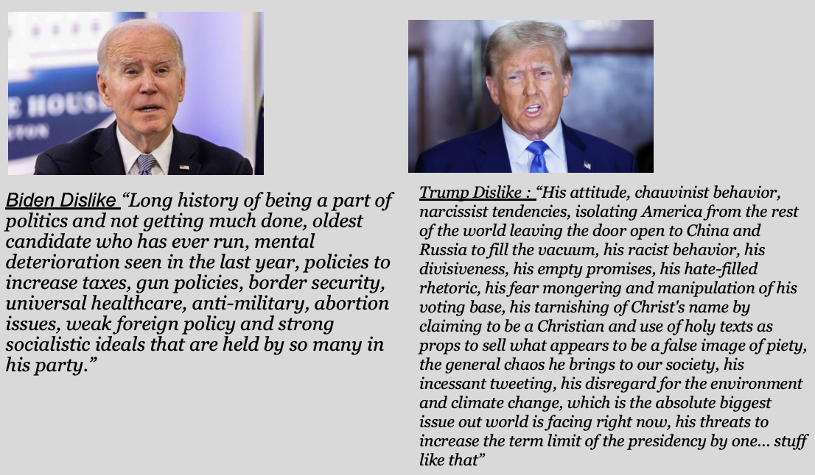

* Source: ANES Open ended responses from 2020 database.

On the next front I coded myself all 800 independents of Coders A or B, once again using the same 35 agreed topics. Additionally, we all provided amendments and made and or eliminated codes where needed to improve the precision of our method. Lastly, we then gathered together and reconciled where my codes and the outside coders differed. Importantly we also took the step of batching our responses into 20 separate batches of 10 responses each. So, each response could get the attention deserved and this step also was helpful in the forthcoming Pilot AI model. The reconciled codes now represent the database of gold standard hand coded results. Statistically for this model I am considering this data to be the data for which we will compare both STM and the Pilot AI analysis, therefore most statistical examinations will be based on how each model performs, in future sections.

## Structured Topic Modeling (STM):

Structured topic modeling has many advantages and disadvantages. One critical advantage is the respective portability of the model. As long the processing capacity is fully used, the model can function using a couple hundred or several thousand textual data. Data, however, must be cleaned in several ways for the Structured Topic Model to function properly. First, the text must be extracted into a corpus, allowing the model to analyze the text together without stop words and other impediments to full analysis. The documents are these critical words, and given the extent of the documents, a vocabulary must be extracted. Following these steps is crucial because of limitations in data gathering or hindrances in the breadth of a vocabulary that will lead to incoherent topics. Some researchers chose to utilize a user-generated vocabulary, given the limitations in some responses. However, for this project, with the relatively large N in samples and distributions, I remain confident in a user-generated dictionary. Another preprocessing step is at what level the K in our model should be set. There is a wide variety of research on this question, but fundamentally, there are agreed-upon conventions to score the effectiveness of each topic level. Most important for our work are four diagnostic criteria: Held-out likelihood, Residuals, Semantic Coherence, and the lower bound. Each model tested will be held to these four criteria across a wide range of topic iterations and then a narrowed set of topic iterations.

The last important preprocessing step is the use of covariate stabilization on the model. This serves to ensure that the “bag of words” approach is fixed within parameters rather than truly scattershot. The packages with the STM diagnostics provide the best approach to enable these covariate stabilizations. For the purposes of our models, I will use several covariates in order to target our topics. They will be Party Identification, Education Level, Ideology, Government Trust, and Age. These covariates represent a mixture of both factor and numeric variables. Covariate stabilization will be utilized particularly in the sampled STM, given the ability for these stabilizations to help increase our coherence across topics for smaller sets. Covariates, in addition to the K-level diagnostics and the text-generated dictionary, give us the best chance of utilizing STM for topic modeling on these responses. Furthermore these additional steps help improve STM’s performance and can provide external validity when new models are piloted, such as an LLM approach [(Tingley et al. 2014)](https://www.zotero.org/google-docs/?p2utWa).

Given the flexible nature of our data availability and STM’s operating power, there was relative quickness for our modeling. So, the STM model is applied to our original set of representative responses (N=800). Two important elements can bolster the reliability of a given STM, they are covariate stabilizations and K diagnostics. For this model I utilized several standard covariates and additional utilized respondent age to further provide stable topics. STM introduces innovation to the aforementioned models by enabling the incorporation of covariates of interest into the prior distributions for document-topic proportions and topic-word distributions. This leads to a model where every open-ended response represents a blend of topics. Instead of presuming that the prevalence of topics (i.e., how often a topic is discussed) and the content of topics (i.e. The words used to discuss them) remain constant across all participants, the analyst can integrate covariates that may exhibit variability, offering a more nuanced understanding. Finally, a fuzzy category was added to help understand the nuanced nature of each derived topic, this specifically is the closest companion to the Hand codes, the raw outcome for this fuzzy category is provided in Appendix C.

### K Diagnostics for Representative Sample

Following the parameters set out above, I processed the subset of data within model A through a diagnostic model to identify the best K level for the model to achieve peak performance. Because this sample is relatively small with N = 800 the vocabulary and covariates will help ensure this smaller model can perform better given the limited nature of responses. Below is a figure featuring the first diagnostic findings. For this initial wave, it’s important to note that I followed a more comprehensive approach and tested K levels from 25 - 45. Once again, you will find the four metrics for measuring the effectiveness of K-level performance: Held-out likelihood, Residuals, Semantic Coherence, and the lower bound.

**Figure 1: Finding K for representative sample - 25 - 45:**  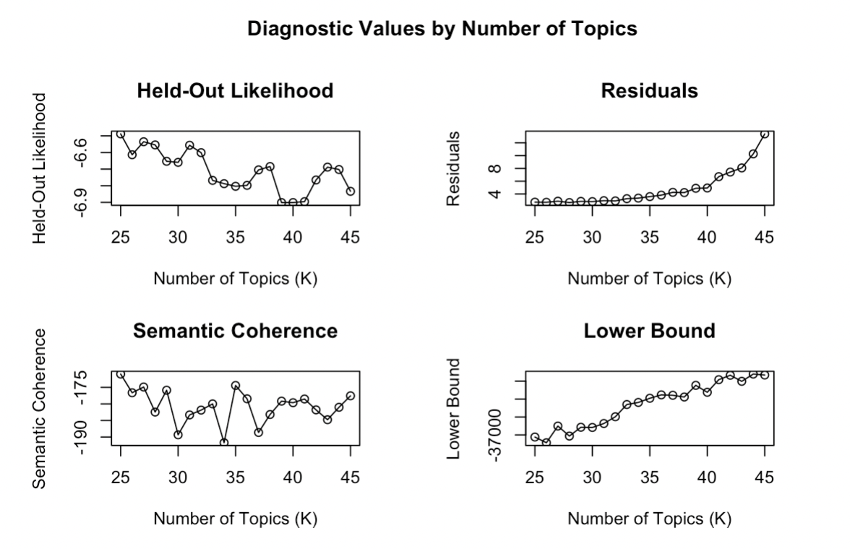

To provide better nuance in how these diagnostic criteria work, I will provide a brief explanation of each component. First, **Held-out Likelihood**: This diagnostic measures how well the model predicts unseen documents. To compute it, the dataset is divided into a training set and a held-out set. The model is trained on the training set, and the held-out likelihood is calculated on the held-out set. A higher held-out likelihood indicates a better model fit. However, this measure alone can favor models with more topics, which might overfit the data. Second, **Residuals**: This refers to the difference between the observed term frequencies in the documents and the term frequencies predicted by the model. Ideally, a good model should have low residuals, meaning that the model can accurately capture the structure of the data. When comparing models with different numbers of topics, one with systematically lower residuals might be preferred. Third **Semantic Coherence**: This measures how much the top words of each topic co-occur in the same documents. A higher semantic coherence suggests that the words within a topic are more meaningfully related to each other. Topics that are semantically coherent are easier to interpret. However, a model with very high coherence might be too focused on word co-occurrence and may not capture diverse aspects of the data well. Lastly, **Lower Bound**: In variational inference, which is often used for estimating STM models, the lower bound (also known as the evidence lower bound or ELBO) is the lower bound on the log-likelihood of the observed data. It's an indicator of model fit; a higher lower bound suggests a better model. During model training, the lower bound should increase as the model parameters are optimized. If the lower bound decreases, it might indicate issues with model convergence or overfitting.

While other diagnostic models exist to inform where to set our K levels, these four metrics provide a snapshot view of what levels perform best to our expectations. Figure 1 presents data that is not completely comprehendible; therefore, I proceeded to re-run the model with a narrower focus. This model was set from 30 to 38 in order for us to evaluate the efficacy of each K level. Figure 2 represents the output from this analysis given the four critical diagnostic criteria. Given the outputs and diagnostics, once we have narrowed down our approach, I opted to set the K level at 33 and 38 topics after topic mapping and cross-referencing outputs with other agreed-upon topic considerations. Given the respective tradeoffs and development considerations, Model A will be set to a K level of 33. With a clear comparison between this and gold-level topic sorting, we will compare the relative impact of this STM model. Following the same approach, I magnified the K-level diagnostics to scan just the levels 30-38. This additional step provides clarity on topic-level selection, particularly with the metric semantic coherence. The initial K diagnostics were limited to 30 - 38, given the complexity of running the model on so many responses.

**Figure 2: Finding K representative sample (Narrowed 30-38):**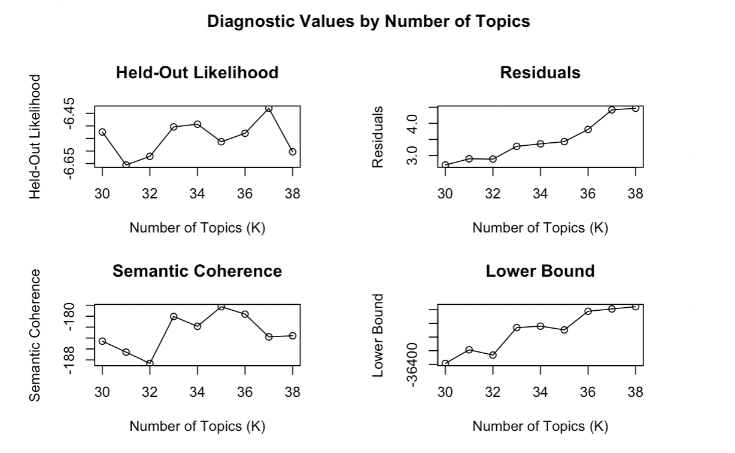

Given the results from this model, an appropriate K level would be 35. In particular, the semantic coherence was optimal at 35. Therefore, the STM will function with 35 topics. In summary, with our clearly set parameters based on the literature and following the logic of structured topic modeling, the K levels are set for the representative sample. Topic mapping is conducted to develop our critical understanding of what each particular topic is speaking to within the context of our constructed design. Below, we will discuss the results from the model with K set to 35. Then, we will examine the efficacy of the STM model as it compares to the empirically coded dataset derived via hand codes.

## STM Model Results

In the first layer, some critical findings emerge from the STM-derived data for our representative sample. First and foremost, it is important to inspect the topic proportions, specifically the prevalence of each topic across the dataset. The model functions as a 4x4 design will only show the prevalence from all four questions but considering the topics created. As attached in the appendix, the coded labels derived from each of the outputs for this model have been derived based on the existing STM diagnostic criteria. Figure three displays the topic prevalence for each of the labeled topics and provides the general nuance of the data derived by STM. Topic probability broadly shows that the top topics include progress, feelings, endorsements, and electability. Interestingly, these topics provide wide dispersion, but in general, personal qualities had a stronger level of prevalence than specific policy concerns. The nature of this data suggests that topics pull across categories and, importantly, provide nuance about where each level lands as a proportion. The general takeaway from these STM-based analyses suggests that our database is weighted particularly towards feelings and progress, while limited prevalence is reserved for policy categories and strictly partisan categories. The STM in itself provides clear insights into the overall nature of the open-ended text in the original given data, however, an inherent limitation in this method is the reliance on probabilistic metrics as opposed to detailed quantifiable derived methods such as hand coding or the piloted AI model. Results and topics will shift frequently (Tingley et al, 2014).

**Figure 3: Topic Probabilities for the 4x4 STM Model**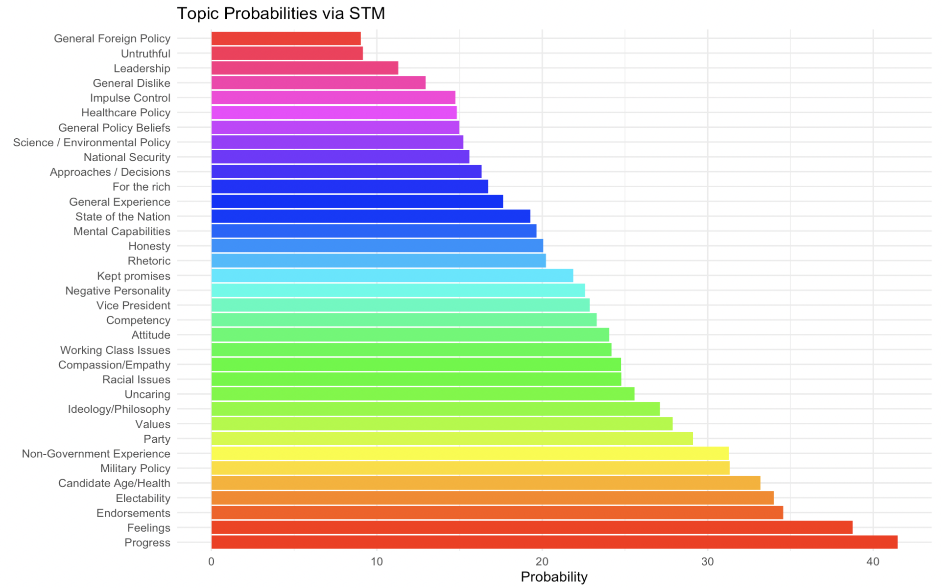

### Setting the prevalence threshold via “theta”

The accuracy of the STM model will be evaluated later. However, the substantive findings derived from the STM provide important insights. Because STM exists in a world of probabilities, hard quantified outputs are not the most natural format for this data. Therefore, to best measure accuracy, the model must be held at a strict coherence threshold where a response would be coded for a specific topic and cross from a 0 = topic is not present to a 1 = the topic is present. The best diagnostic step to gather this dataset would be to find an acceptable coherence threshold. Based on a looped analysis that measured relative coherence and emerging topic prevalence, 15% was the most acceptable among other tested levels. The goal of balancing these coherence thresholds is serving among two poles. First, if the coherence threshold is set too high, then no topics are discovered, and therefore, almost all responses will be given back at 0. If the threshold is too low, then almost every response would qualify to be assigned to a topic. Figure 4 below demonstrates how the process of testing acceptable coherence thresholds looked over 100 iterations. This operation was accessible via the STM “theta” function.

**Figure 4: Prevalence Threshold Identification looped for 100 iterations (15% in green)**

## Experimental GPT-4 Analysis

Now, given the nuances of how STM was utilized within our methodological framework. I will introduce the piloted Generative Pre-trained Transformer (GPT) GPT-4 model. Importantly, methodological processes dictate that the use of large language models be strategically deployed over several iterations [(Pham et al. 2023)](https://www.zotero.org/google-docs/?eK81Xg), while no formalized process is agreed upon. Model development and machine learning approaches allow models to gather effective coherence ([Phillips, Davidson, and Baffoe-Bonnie 2023](https://www.zotero.org/google-docs/?8j9djC)). However, for this pilot analysis, I utilized the existing infrastructure of the front and accessed GPT -4 via open AI. The model began with a simple dialogue explaining the task of coding for several hundred open-ended responses and providing the specification for each of the 35 topics (as attached in appendix B). Four dialogues were then developed for each position for appropriate coding. Then, I sent forward 20 batches of 10 responses after the codes were retrieved, I asked the bot to take a look at the correct hand codes and find any discrepancies between its perceived codes and the hand codes. After processing each batch, I then asked the bot to amend our current topics and be ready to handle the next batch. As the script continues, the model is quicker, asks fewer questions, and makes fewer mistakes when we get to the final 200. The output from the model now exists in an archived dialogue, from which I scrapped all of the codes and sorted them by response ID number.

This process repeats for the exact 200 responses for each of the four questions we look to examine, further bolstering our efforts to code these topics using an AI-derived model effectively. Utilizing Large Language Models for this task provides two key insights: AI works really well for a wide range of applications but also fails to pick up respective nuances. While this is a similar complaint to STM, the AI itself can speak to you and ask clarifying questions as well as provide a rationale for its decisions. Below in Table 4 is an example of some of this important dialogue that was needed to gather accurate information. As structured, the model will inherently improve as more hand codes are revealed. Furthermore, the GPT-4 model was asked to continually return the original hand codes and revise the criteria as it continued working on the data. Each of the four questions for candidate likes and dislikes had its own model script, and feedback was provided for each topic considered for a given response.

**Table 3: GPT-4 Process Tracing**

|  |  |  |  |  |  |
| --- | --- | --- | --- | --- | --- |
| Stage 1: | Stage 2: | Stage 3: | Stage 4: | Stage 5: | Stage 6: |
| Start with Topics | General Example | First Batch | Compare to hand codes | Amend the 35 original | Next Batch |
| Presenting 35 topics (as in Appendix B) | I provide an example of ONE response that qualifies for coding. | Supply Batch 1 for coding 10 responses (This is often the most incorrect) | Then compare to the correct coding from hand codes for that 10 | Then look at any affected codes and update the criteria | Supply Batch 2 for coding another 10 responses |

**Table 4: Example of GPT-4 Feedback**

|  |  |  |  |  |
| --- | --- | --- | --- | --- |
|  | Myself | GPT-4 Response | Myself | GPT-4 Response |
| Simple Response | 430113 : NOT SUITABLE FOR ANY GOVERNMENT ROLE | 430113  13) Personality - Leadership: Not suitable for any government role implies a critique of leadership ability. | Now compare with these hand codes:>  13 | 430113  Both Codings: 13 (Personality - Leadership)  Analysis: Agreement on the unsuitability for government roles, focused on leadership. |
| More Difficult Response | code this response:> 429953  His lack of morals. His entitlement attitudes. His inability to tell the truth. He is stupid. He doesn’t educate himself before making decisions. He doesn’t listen to advice from experts. He is stupid. He doesn’t wear a mask | 429953  11) Personality - Honesty: Inability to tell the truth.  14) Personality - Other: Lack of morals, entitlement attitude, not wearing a mask, and failure to educate himself or listen to expert advice.  12) Personality - Intelligence: Described as stupid, implicating intelligence issues. | Now compare with these hand codes:>  429953  11, 12, 13, 30 | 429953  My Coding: 11 (Personality - Honesty), 14 (Personality - Other), 12 (Personality - Intelligence)  Hand Codes: 11, 12, 13 (Personality - Leadership), 30 (Public Health / Covid)  Analysis: The inclusion of leadership (13) and specific mention of Covid-19 handling (30) in the hand codes was missed in my interpretation. |

## Results - A three-step approach

On first glance you can determine the efficacy of a given model by how frequently responses were coded within a given set of categories. In an effort to provide the most clear and concise measure of relative effectiveness of a given model. I seek to evaluate using the shared major categories. These mapped on neatly to our provided hand codes and additionally provided critical structures for STM to generate on its own fruition. The major categories which are a shared attribute across all three models (STM, AI, and Hand Codes) are the variable of interest in our analysis. The best vehicle to measure the efficiency of these coding operations is a strict Pearson correlation test for which we subject STM derived major categories and AI derived major categories. Results will take a three-step approach, first the descriptive count data will be provided for each of the three models. Next a count correlation test will be conducted across all major categories, with particular attention to weighting larger categories and a Pearson correlation metric will be provided for the STM derived model and for the AI derived model. Finally, a detailed correlation matrix is presented for both the STM-HAND model and the AI-HAND model.

### Nature of the data and count correlation - Hand codes vs STM and AI

Immediately there are interesting divergences between how each model comprehends and provides counts for each major category. Hand coded frequencies match much more closely to the AI derived model in this particular dataset. The STM derived model performs somewhat closer in the nature of what the data provides but fails to recognize the full magnitude of responses in a given category. While the STM derived model performs in methods that were not exclusively the use of the data, there is a somewhat of symbiotic relationship when considering the raw frequencies among all three models. But particularly when providing coherent and identical matching the AI derived model is unparalleled in seeking out the efficient coding structure. Figure 5 relays the full frequency distribution of the nine major categories across all three of the models discussed in this analysis. The N of this official dataset is (N=800) representing 200 randomly selected candidate likes and dislikes respectively. The nature of this data is predisposed to provide more personality qualities then other categories of codes. Since this is overweight, a strict correlation test which considers Hand coded results as the gold standard data helps to clarify what relationships are present within the model. All things considered the departure point for STM and AI come at the magnitude but both models are recognizing the broad nature of the data.

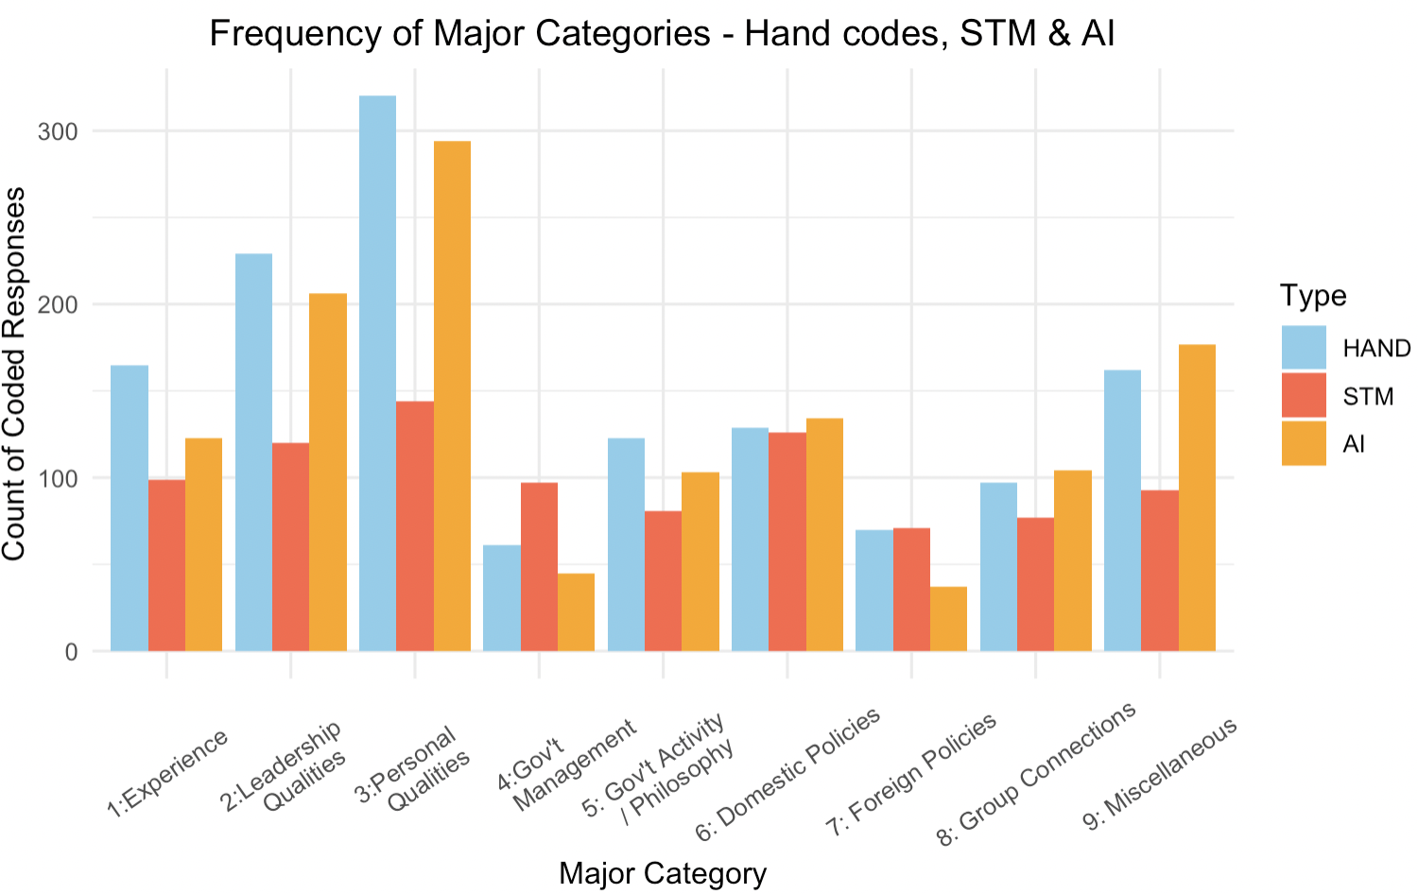**Figure 5: Major Category frequency distribution across all three models**

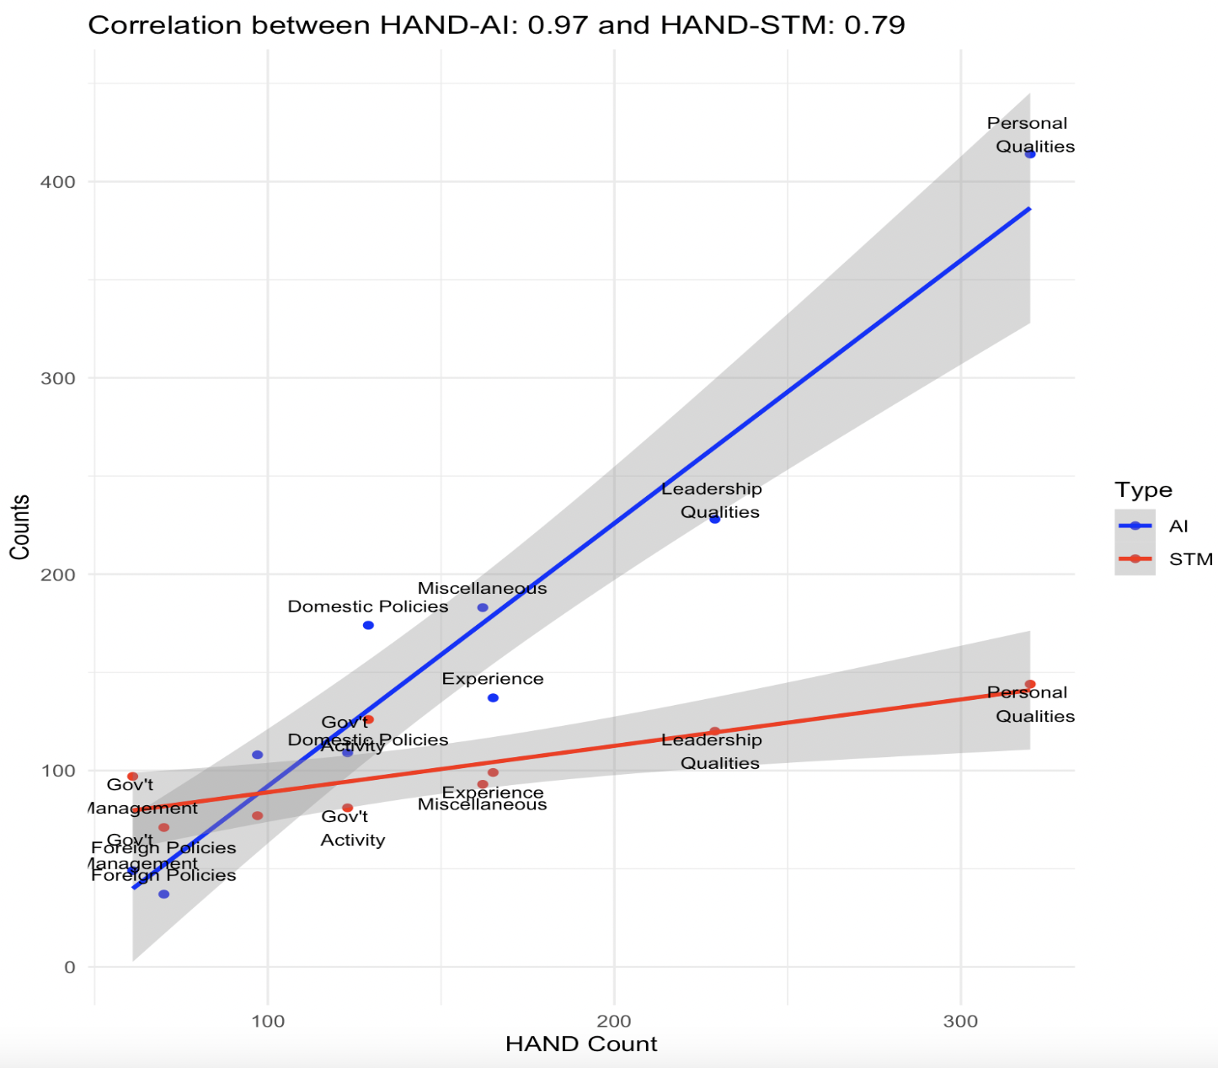 In a more favorable development for STM we can see that from a strict count correlation and holding both models to the relative performance of 100% for the hand coded data that both STM and AI derived models perform well at being correlated with results from the hand coded database. The Pearson correlation for both AI and STM model is presented in figure 6. Importantly because category three was so prevalent, it was important to examine the count data regressed over the counts of each model. The HAND-AI model produced an exceptional Pearson correlation coefficient of (0.97) while the HAND-STM model also provided a high correlation of (0.79). Providing all details considered, the STM model would not necessarily be discounted as inaccurate, in particular given the nuance and flexibility of the model as it performs with respect to the limitations of the AI derived model. However, the utility of STM at least in the manner in which it has currently been constructed does seem to fall apart in accuracy for larger categories, this is particularly true given the divergence of correlations within major category 3.

**Figure 6: Pearson’s Correlation for HAND-AI and HAND-STM models**

*Pearson correlation coefficient provided for all counts for each of the 9 categories given the outputs from each database.

### Correlation test - coherence for each compared model

Next, we move to a critical step to measure the performance for each major category across all of the nine major categories. With the inherent goal of determining model performance and indeed specific model agreement across all nine categories, I provide Pearson correlation findings for each category when compared to the hand coded results. Figure 7 provides an ideal representation of the discernible findings for the combined correlation matrix. Ideally the best performing models would show a positive (green) correlation on the diagonal within this matrix. STM-HAND performs relatively poorly at this task.

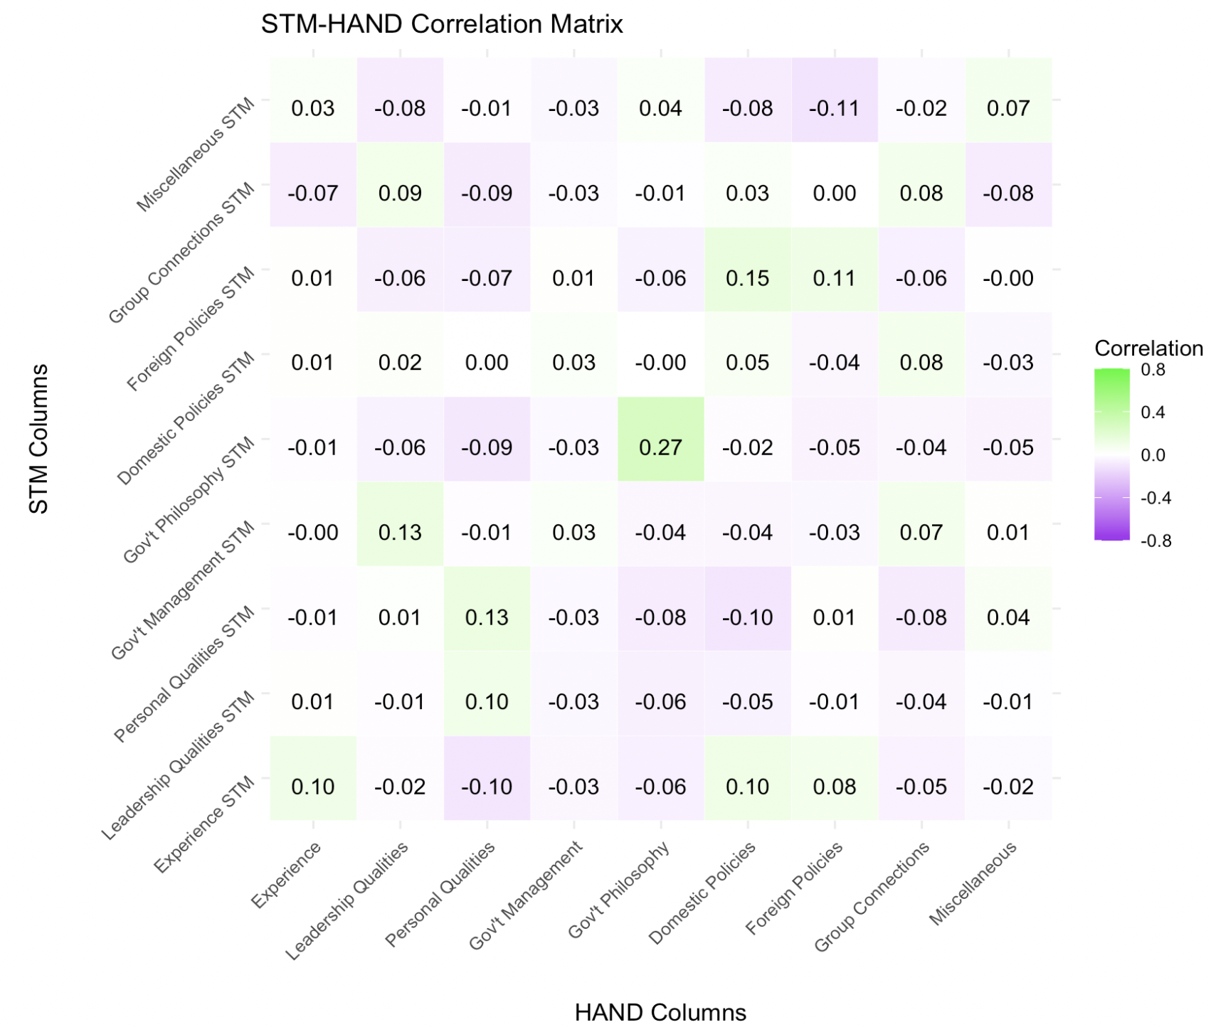**Figure 7: STM-HAND Correlation Matrix**

The correlation was particularly notable in several major categories such as "Leadership Qualities" and "Personal Qualities," suggesting that STM is more reliable in capturing themes related to personal attributes of political figures. However, categories involving more nuanced topics or those requiring deeper contextual understanding showed less consistency. Clearly The coherence thresholds established for STM affected its performance. Setting appropriate coherence levels was crucial for ensuring that the topics generated by STM were meaningful and closely matched the hand-coded categories. The findings suggest that while STM can identify broad themes effectively, its precision in matching the nuanced understanding of human coders varies. While the nuance is lacking in the general correlation of the findings, bound topics and newly generated topics were reasonably stronger. See appendix for “find thoughts” and STM output for more clarity.

Now if we subject the AI-HAND model to the same evaluation we find among one of the most important methodological cleavages in the utilization of AI for this task. Recalling back to our process tracing steps, the AI based model can learn, adapt and be trained to incorporate critical nuances that emerge from a given text. Leveraging this a critical finding emerges that for this specific task the AI derived model performance at a significantly higher coherence. Figure 8 provides the topic-based correlation matrix which tests the AI-HAND model across the nine major categories.

**Figure 8 AI - HAND Correlation Matrix**

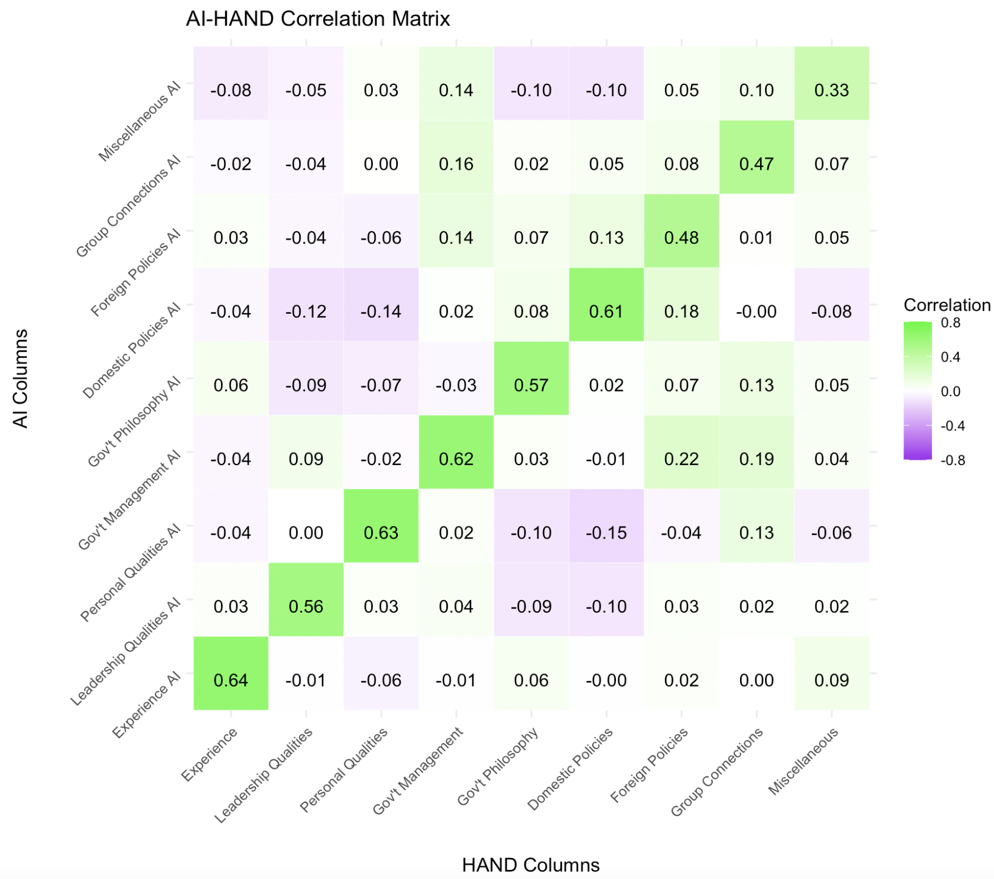

Critically, as established in previous effective coding measures, the correlation of results is exceptional when utilizing the AI-based model. Some major categories performed significantly higher than expected; in most of the literature cited before, the key distinction within the HAND-AI model is the ability to learn while processing. STM, while valuable in developing themes, fails to improve over a large amount of data. While this test sample is relatively small, the HAND-AI model could proceed to code a full dataset without much of the coherence changing. The best case within our correlation matrix is topic 3, personal qualities. This topic has a hand-coded N of 320 or so, which is significantly larger than most of the other categories. However, when comparing this large and diverse group of codes and responses, STM provides a correlation of 0.13, while AI provides a correlation for the same response of 0.63 when both are compared to the gold standard hand-coded data. Finally, the results do suggest that by leveraging the front-end consumer-level AI-derived models' ability to produce clear results, we can formalize this process and engage the model using the API developed for our tested methods and further seek to bolster model coherence. For this specific task, STM does not have that same room for improvement.

## Discussion - Implications for the future

## The examination of topic coding methodologies for open-ended responses within the 2020 American National Election Study has provided crucial insights into the effectiveness and limitations of different analytic approaches. This study highlighted the comparative accuracies of hand-coding, structured topic modeling (STM), and AI-assisted models, offering a nuanced understanding of their application in political science research. Hand-coding, while labor-intensive, remains the gold standard due to its precision in capturing the nuanced expressions of respondents' likes and dislikes towards political figures. However, the scalability issues associated with hand-coding necessitate the exploration of automated methods, especially in handling larger datasets typical of national surveys.

The STM approach, bolstered by recent advancements in covariate stabilizations, presents a viable alternative, offering substantial utility through its relative simplicity and adaptability. Yet, its effectiveness is contingent on the correct pre-processing of texts, which poses a challenge in ensuring the accuracy of topic assignments. Emerging prominently in this study is the potential of AI-assisted models, which are beginning to match the coherence and accuracy of traditional methods. The adaptability of AI models, especially with ongoing improvements in natural language processing algorithms, supports their use in dynamic research environments. These models can handle large volumes of data efficiently, potentially surpassing traditional methods in speed and scalability without significant loss of accuracy. Future research should focus on refining AI models to enhance their interpretative capabilities and ensure that they can maintain consistency with established coding standards. As political discourse continues to evolve, the ability of AI to adapt to new contexts and nuances will be critical.

Critically, the lessons from both models leave us with several specific benefits and drawbacks for both models. STM offers, at the moment the best-automated scalability, particularly in handling large datasets, which is a common challenge in major surveys. Unlike manual coding, STM can process vast amounts of text rapidly, reducing the time and labor costs associated with data analysis. STM also allows researchers to incorporate metadata or covariates (like demographic information) into the modeling process. For this presented model, we could extract specific covariates and determine their relative effect on the data. Finally, by converting qualitative text into quantifiable data, STM facilitates statistical analysis of themes and sentiments expressed across a population. This capability is particularly valuable in measuring the prevalence and significance of certain topics over others.

However, some important drawbacks have emerged in this paper, particularly in terms of coherence and interpretation. STM can provide important insights into the probabilistic nature of open-ended data, however, the model can require some fine-tuning and indeed, poorly coherent data when we take the step of pulling these probabilities into a hard count. While STM can identify dominant topics within text data, interpreting these topics often remains subjective and requires additional qualitative analysis. The model's outputs may not always correspond directly to intuitive or meaningful categories without substantial human oversight.

Some important conclusions emerged from this analysis for the AI-derived model. First, unlike STM, the AI model is using an iterative approach. AI models, particularly those based on deep learning, can improve over time through continued training on new data. This adaptability makes them highly effective in dynamic research environments where discourses and language use evolve. When thinking about the likes and dislikes of a candidate, it's very clear that this question is uniquely prone to shifts in interpretation and language specific to a given election cycle. The coherence for this task is unexpectedly strong, particularly considering the limitations of using GPT-4 on the front end.

Future developments for this project include using a larger and more systematic hand-coded gold standard database for comparing coherence. A good candidate for this would be the 2008 ANES open-ended coding project outcomes for candidate likes and dislikes. There are some other avenues to explore on the STM front, including using a manually refined dictionary, and perhaps shifting around covariates, as well as implementing a different theta level for determining STM coherence. On the AI front, the utilization of the open.ai API system includes being able to provide strategic training for the bot on each specific topic and provide sample data for the model to work on before annotating text. Lastly, this evaluation unlocks several possible new roads for exploration, including analysis that were previously dependent on the ANES open ended codes, which have not been available since 2008.

## Bibliography:

[Argyle, Lisa P., Ethan C. Busby, Nancy Fulda, Joshua R. Gubler, Christopher Rytting, and David Wingate. 2023. “Out of One, many: Using Language Models to Simulate Human Samples.” *Political Analysis* 31(3): 337–51. doi:10.1017/pan.2023.2.](https://www.zotero.org/google-docs/?Dh99qA)

[Campbell, Angus, University of Michigan, and University of Michigan, eds. 1960. *The American Voter*. Unabridged ed. Chicago [Ill.]: University of Chicago Press.](https://www.zotero.org/google-docs/?Dh99qA)

[Campbell, Angus, University of Michigan, and University of Michigan, eds. 1980. *The American Voter*. Unabridged ed. Chicago [Ill.]: University of Chicago Press.](https://www.zotero.org/google-docs/?Dh99qA)

[“Coding Open-Ended Answers to Questions Measuring Reasons to Vote for or against Candidates from the 2008 ANES Time Series Interviews.”](https://www.zotero.org/google-docs/?Dh99qA)

[Eshima, Shusei, Kosuke Imai, and Tomoya Sasaki. “Keyword-Assisted Topic Models.” *American Journal of Political Science* n/a(n/a). doi:10.1111/ajps.12779.](https://www.zotero.org/google-docs/?Dh99qA)

[Lupia, Arthur. 2018. “How to Improve Coding for Open-Ended Survey Data: Lessons from the ANES.” In *The Palgrave Handbook of Survey Research*, eds. David L. Vannette and Jon A. Krosnick. Cham: Springer International Publishing, 121–27. doi:10.1007/978-3-319-54395-6_16.](https://www.zotero.org/google-docs/?Dh99qA)

[Mellon, Jonathan, Jack Bailey, Ralph Scott, James Breckwoldt, Marta Miori, and Phillip Schmedeman. 2024. “Do AIs Know What the Most Important Issue Is? Using Language Models to Code Open-Text Social Survey Responses at Scale.” *Research & Politics* 11(1): 20531680241231468. doi:10.1177/20531680241231468.](https://www.zotero.org/google-docs/?Dh99qA)

[Pham, Chau Minh, Alexander Hoyle, Simeng Sun, and Mohit Iyyer. 2023. “TopicGPT: A Prompt-Based Topic Modeling Framework.” doi:10.48550/ARXIV.2311.01449.](https://www.zotero.org/google-docs/?Dh99qA)

[Phillips, Julie A., Thomas R. Davidson, and Marilyn S. Baffoe-Bonnie. 2023. “Identifying Latent Themes in Suicide among Black and White Adolescents and Young Adults Using the National Violent Death Reporting System, 2013–2019.” *Social Science & Medicine* 334: 116144. doi:10.1016/j.socscimed.2023.116144.](https://www.zotero.org/google-docs/?Dh99qA)

[Roberts, Margaret E., Brandon M. Stewart, and Edoardo M. Airoldi. 2016. “A Model of Text for Experimentation in the Social Sciences.” *Journal of the American Statistical Association* 111(515): 988–1003. doi:10.1080/01621459.2016.1141684.](https://www.zotero.org/google-docs/?Dh99qA)

[Tingley, Dustin, Christopher Lucas, Jetson Leder‐Luis, Shana Kushner Gadarian, Bethany Albertson, David G. Rand, and Margaret E. Roberts. 2014. “Structural Topic Models for Open‐Ended Survey Responses.” *American Journal of Political Science* 58(4): 1064–82. doi:10.1111/ajps.12103.](https://www.zotero.org/google-docs/?Dh99qA)

## 

## 

## Appendix A - Supplemental Analysis:

A-1: 35 Topic Full Correlation Matrix

*STM provided via 15% coherence threshold *Hand codes are fuzzy matched to the closest corresponding category see STM topic mapping table below for direct matches. *Hand columns with (.x) values denotes multiple Fuzzy matches for STM onto the same hand codes

## AI-HAND

* This topic-to-topic correlation matrix utilized the same methodology for the top. Some categories in the AI derived model returned no results, so therefore the data within the column is held at 0.00.

## Appendix B - Hand-coded Annotation Rules:

These are the guidelines provided for the coding team as they worked on coding the distinct topics for the 2020 responses. Codes were loosely developed and adapted from Krosnick and Lupia's ANES 2008 open-ended codes

## Project Summary:

Our objective is to code open-ended responses given in the 2020 presidential elections. For this particular element of the survey, 200 unique respondents were asked four questions.

* What is it that you **like** about **Joe Biden**
* What is it that you **dislike** about **Joe Biden**
* What is it that you **like** about **Donald Trump**
* What is it that you **dislike** about **Donald Trump**

For these responses, we are looking for what particular topics were mentioned among 35 agreed-upon topics. These topics are across all four questions, and a response can carry one or several topics depending on the particular response. Below is a table of all 35 topics, with the respective criteria for a topic to be satisfied

## 35 Topics for all four questions

|  |  |  |  |
| --- | --- | --- | --- |
| # | Label | Annotation Criteria | Larger Categories |
| 1 | General | Good person, bad person, likable, not likable, I like him, I do not like him - Any allusions to a general feeling toward a candidate. Everything but not specific. | Miscellaneous |
| 2 | Party | Is (or is not) a Democrat, is (or is not) a member of the Democrat Party, is (or is  not) a Republican, is (or is not) a member of the Republican Party, is (or is not) | Government Activity |
| 3 | Ideology / Philosophy / Views | Conservative, liberal, socialist, Marxist, communist, fascist, libertarian, moderate, America First or MAGA share my views, or I oppose his views. | Government Activity |
| 4 | Electability | Can win, cannot win | Experience |
| 5 | Better than alternative | Not Trump, Not Biden, Lesser of two evils | Leadership Qualities |
| 6 | Political experience | Political experience, work the candidate has done as a politician or elected official, “experienced” or “inexperienced” in general. Positive or negative. “Insider” and like the current job of an incumbent. Record | Experience |
| 7 | Non-Political experience | Business experience, work the candidate has done in business, industry, or  Education. Also, “outsider” sentiments or reasons for support | Experience |
| 8 | Scandal / Cover-up | The candidate was involved in a scandal or cover-up | Miscellaneous |
| 9 | Other past activity | Any mention of something the candidate did in the past that does not match  another code, for example trump’s twitter usaged | Miscellaneous |
| 10 | Personality - Ability | The candidate's ability to accomplish a task or get the job done. Keeping promises and fulfilling objectives | Leadership Qualities |
| 11 | Personality - Honesty | The candidate's honesty, integrity, consistency, predictability, sincerity, empathy  Truthfulness, character “Cares about people like me” | Personal Qualities |
| 12 | Personality - Intelligence | The candidate's intelligence | Personal Qualities |
| 13 | Personality - Leadership | The candidate's ability to lead, get people to work together, make people want to  follow, inspire people, inspire the respondent, motivate people, motivate the  respondent. Strong or weak Leader “fights for people like me”. Also, Patriotic sentiments | Leadership Qualities |
| 14 | Personality - Other | Anything about the candidate’s personality that does not match the description above | Personal Qualities |
| 15 | Candidate Health / Mental Fitness | The candidate's health and mental sharpness. Age. | Personal Qualities |
| 16 | Religion | The candidate does, or does not, belong to a specific religious group. The candidate is religious or not religious. Also advances a religious agenda. | Personal Qualities |
| 17 | Education | The candidate’s education, where the candidate went to school or college, the candidate’s type of diploma or college degree | Personal Qualities |
| 18 | Physical Appearance | The candidate's physical appearance, attractiveness, how good the candidate looks | Personal Qualities |
| 19 | Demographics | The candidate's age, sex, sexual orientation, race, ethnicity, height, weight,  marital status, or where the candidate is from | Personal Qualities |
| 20 | Policy - Economic | What the candidate will do about the economy, taxes, government spending, the  budget, the deficit, and the national debt? The candidate’s policy, stand, views, position, or emphasis on the economy, taxes, government spending, the budget, the deficit, the national debt. Covid stimulus, and other economic or fiscal concerns | Domestic Policies |
| 21 | Policy - Poor People | What the candidate will do about government programs to help poor people. The candidate’s policy, stand, views, position, or emphasis on government programs to help poor people. General For the people sentiments  NOTE: This code should be only assigned to ideas that mention helping poor people or government programs to help poor people. Examples of government programs to help poor people include welfare, food stamps, Medicaid, Aid for Families with Dependent Children (AFDC), and public housing. Any idea that mentions how much the candidate cares about poor people is assigned to the **“groups”** code (26) | Domestic Policies |
| 22 | Policy - Liberty | What will the candidate allow people to do, prevent people from doing, or make legal or illegal. The candidate’s policy, stand, views, position, or emphasis on what people should be allowed or prevented from doing or what activities should be legal or illegal.  Abortion, LGBTQ policy, and Marijuana are some examples | Domestic Policies |
| 23 | Policy - International Affairs | How will the candidate deal with other countries in general, foreign policy in general, and the reputation of the United States? The candidate’s policy, stand views,  position, or emphasis on other countries in general, foreign policy in general, and the reputation of the United States. Also support or opposition to military. | Foreign Policies |
| 24 | Policy - Judiciary | Supreme court, judicial appointments, and court packing. Any other illusions to judicial policy | Domestic Policies |
| 25 | Policy - Other | What will the candidate do about something that does not match a description in  codes 20-24. The candidate’s policy, stand views, position, or emphasis on  something that does not match a description in codes 20-24. | Domestic Policies |
| 26 | Groups | The candidate's support for or opposition to ideological or other groups. feelings about a specific group of people. Also, attacks on candidates' supporters | Group Connections |
| 27 | Emotions / Feelings | The candidate makes the respondent feel happy, sad, angry, proud, afraid, scared | Miscellaneous |
| 28 | Candidate - Other | Any mention of something about Trump / Biden that does not match another code | Miscellaneous |
| 29 | Non - Candidate | Any mention of something other than the candidate and that is not about the respondent | Miscellaneous |
| 30 | Public Health / Covid | Both pro and anti-Covid mitigation. Masks, lockdowns, school closures. Health infrastructure, Vaccines, and other covid specific mentions | Government Management |
| 31 | Democracy / Voting Rights | Election Fraud, Voter suppression, ballot access, democratic insecurities, mail in voting, abuses of power, saving democracy, fear of dictatorship, or rolling back voting access, etc. | Government Management |
| 32 | Racial Issues / Policing | BLM, George Floyd, racial equality, defund the police, and other broad illusions to racial justice or racial resentment (Close to code 26 but specifically focused on racial issues). Also, law and order and pro-police sentiments. | Group Connections |
| 33 | Running Mate / Endorsement | Running mate (Kamala Harris or Mike Pence). Or key endorsements from respected political or non-political figures (Party Luminaries) such as  James Clyburn for Biden or  Jerry Falwell Jr. for Trump | Experience |
| 34 | Don’t Know | I don’t know, don’t know, DK, I’m unsure, I’m not sure, Unsure, You got me, I  can’t remember, I have no clue, no clue, I have no idea, No idea, No guess, no, nothing | Miscellaneous |
| 35 | All others | Any statement that does not fit the codes | Miscellaneous |

## Steps for coding:

1. Take a response and read it in detail, for example, take this response from Joe Biden - Likes :

**“He isn't Donald Trump. He shares my view of what America stands for. I want to save our democracy.”**

1. In my view, there are a few topics mentioned in this response.

* 5) Better than the alternative
* 3) Ideology / Philosophy
* 31) Voting rights

However, this is subjective; read through and fully vet each answer, but there is no truly correct way to code these responses. Do your best and be sure you have a reason for how you coded this particular response any particular way. Remember that all responses can have up to as many codes as you would like to assign.

## Appendix C STM Topic Mapping - with Raw STM Data

Full table of all three categories of codes

|  |  |  |  |
| --- | --- | --- | --- |
|  | Major Categories | Corresponding STM Topics | Corresponding Hand-Coded Topics |
| 1 | Experience | * 26: Experience * 28: Non-Government- Experience * 32: Electability | * 6: Political Experience * 7: Non-Political Experience * 33: Running Mate / Endorsement * 4: Electability |
| 2 | Leadership Qualities | * 4: Compassion/Empathy * 15: Competency * 24: Mental Capabilities * 33: Leadership * 6: Better than alternative | * 5: Better than the alternative * 10: Personality - Ability * 13: Personality - Leadership |
| 3 | Personal Qualities | * 2: Impulse Control * 9: Negative Personality * 11: Candidate Age/Health * 17: Honesty * 20: Untruthful * 31: Uncaring | * 11: Personality - Honesty * 12: Personality - Intelligence * 14: Personality - Other * 15: Candidate Health / Fitness * 16: Religion * 17: Education * 18: Physical Appearance * 19: Demographics |
| 4 | Government Management | * 13: Government Management * 21: Approaches / Decisions * 25: Kept Promises * 22: Covid | * 30: Public Health / Covid * 31: Democracy / Voting Rights |
| 5 | Government Activity / Philosophy | * 12: Ideology / Philosophy * 27: Party * 34: Progress | * 2: Government activity * 3: Ideology / Philosophy |
| 6 | Domestic Policies | * 1: Working Class Issues * 5: Science/Environmental Policy * 18: Healthcare Policy * 26: Military Spending * 30: General Policy Beliefs | * 20: Policy - Economic * 21: Policy - Poor People * 22: Policy - Liberty * 24: Policy - Other |
| 7 | Foreign Policies | * 14: Military Policy * 23: National Security * 35: General Foreign Policy | * 23: Policy - International Affairs |
| 8 | Group Connections | * 3: Racial Issues * 29: Values | * 26: Groups * 32: Racial Issues |
| 9 | Miscellaneous | * 8: Feelings * 16: General Dislike * 19: For the rich | * 1: General * 8: Scandal / Coverup * 9: Other Past Activity * 27: Emotions / Feelings * 28: Candidate - Other * 29: Non - Candidate * 34: Don’t Know * 35: All others |

|  |  |  |  |  |
| --- | --- | --- | --- | --- |
|  | **Raw STM Data** | Label | Major Cat | Fuzzy |
| 1 | Topic 1 Top Words:  Highest Prob: work, class, peopl, make, tri, care, fight  FREX: class, work, fight, middl, tri, make, profession  Lift: cours, john, mistak, rise, class, fight, work  Score: work, class, john, fight, middl, tri, mistak | Working Class Issues | Domestic Policies | (21) Policy - Poor People |
| 2 | Topic 2 Top Words:  Highest Prob: left, mouth, never, polici, far, decis, peopl  FREX: mouth, never, left, answer, far, agenda, puppet  Lift: engag, subject, mouth, answer, fund, although, mislead  Score: subject, mouth, engag, answer, left, agenda, never | Impulse Control | Personal Qualities | (14) Policy - Other |
| 3 | Topic 3 Top Words:  Highest Prob: trump, donald, racist, better, presid, bigot, biden  FREX: donald, trump, bigot, better, pathet, racist, preditor  Lift: bigot, pathet, preditor, donald, trump, excus, cater  Score: trump, donald, preditor, bigot, pathet, better, racist | Racial Issues | Group Concerns | (32)  Racial Issues / Policing |
| 4 | Topic 4 Top Words:  Highest Prob: like, everyth, honest, man, fact, concern, human  FREX: honest, everyth, like, man, decent, fact, may  Lift: oppos, decent, honest, everyth, least, empathet, like  Score: like, everyth, honest, oppos, man, fact, decent | Compassion  /Empathy | Leadership Qualities | (11) Personality - Honesty |
| 5 | Topic 5 Top Words:  Highest Prob: scienc, direct, incompet, will, countri, spend, environ  FREX: direct, scienc, spend, environ, wear, destruct, expert  Lift: destruct, wear, environ, expert, direct, spend, scienc  Score: wear, spend, environ, direct, scienc, expert, doesn’t | Science / Environmental Policy | Domestic Policy | (25)  Policy - Other |
| 6 | Topic 6 Top Words:  Highest Prob: experi, build, relationship, offic, better, social, world  FREX: experi, build, relationship, small, pass, charact, damag  Lift: pass, experi, build, small, restor, near, popul  Score: experi, pass, relationship, build, restor, damag, system | Better then alternative | Experience | (6) Political Experience |
| 7 | Topic 7 Top Words:  Highest Prob: nation, countri, lot, touch, current, good, presid  FREX: nation, current, touch, child, lot, hate, real  Lift: child, nation, congress, faith, current, sociopath, end  Score: child, nation, current, touch, hate, fascist, congress | State of the Nation | Government Managment | (8) Scandal / Coverup |
| 8 | Topic 8 Top Words:  Highest Prob: feel, mani, countri, see, like, america, politician  FREX: feel, see, mani, yet, don’t, divis, mind  Lift: topic, yet, see, don’t, unifi, healthi, feel  Score: yet, feel, see, mani, divis, don’t, unifi | Feelings | Miscellaneous | (27) Emotions - Feelings |
| 9 | Topic 9 Top Words:  Highest Prob: hes, offic, real, need, asshol, crazi, everyon  FREX: hes, asshol, crazi, real, offic, pervert, trustworthi  Lift: hes, asshol, crazi, pervert, joke, trustworthi, real  Score: hes, crazi, offic, asshol, real, need, trustworthi | Negative Personality | Personal Qualities | (11) Personality - Honesty |
| 10 | Topic 10 Top Words:  Highest Prob: say, thing, lie, peopl, way, pandem, racist  FREX: say, thing, way, lie, selfish, love, pandem  Lift: egotist, emot, unstabl, immor, selfish, say, sexist  Score: say, emot, lie, selfish, egotist, liar, unstabl | Rhetoric | Miscellaneous | (30) Public - Health - Covid |
| 11 | Topic 11 Top Words:  Highest Prob: realli, old, speak, isnt, age, stand, mind  FREX: realli, isnt, speak, lifelong, old, prefer, age  Lift: bare, dement, excel, lifelong, isnt, prefer, manner  Score: lifelong, realli, speak, old, isnt, age, ethic | Candidate Age/Health | Personal Qualities | (15) Candidate Age - Health |
| 12 | Topic 12 Top Words:  Highest Prob: countri, socialist, help, want, peopl, make, togeth  FREX: socialist, togeth, help, viewpoint, bring, want, arrog  Lift: viewpoint, choos, socialist, ration, shape, decenc, environment  Score: viewpoint, socialist, togeth, help, bring, becom, choos | Ideology  /Philosophy | Government Philosphy | (3) Ideology / Philosophy |
| 13 | Topic 13 Top Words:  Highest Prob: presid, know, will, vice, polit, hous, white  FREX: vice, know, presid, happi, hear, hous, second  Lift: half, happi, common, vice, hear, second, sexual  Score: happi, presid, vice, know, hear, hous, second | Vice President | Government Managment | (33) Running Mate / Endorsement |
| 14 | Topic 14 Top Words:  Highest Prob: good, polici, believ, view, militari, econom, economi  FREX: good, econom, view, believ, polici, militari, brought  Lift: brought, cathol, murder, strength, businessman, econom, background  Score: polici, good, view, econom, believ, strength, militari | Military Policy | Foreign Policy | (23) Policy - International Affairs |
| 15 | Topic 15 Top Words:  Highest Prob: think, will, set, know, time, tax, america  FREX: set, think, ridicul, know, speak, creat, china  Lift: home, usa, set, creat, think, israel, ridicul  Score: think, set, ridicul, creat, speak, school, spend | Competency | Leadership Qualities | (10) Personality - Ability |
| 16 | Topic 16 Top Words:  Highest Prob: dont, run, want, just, trust, state, mate  FREX: dont, run, capabl, trust, just, mate, want  Lift: capabl, fool, clue, dont, mate, run, trust  Score: dont, run, mate, trust, fool, just, want | General Dislike | Miscellaneous | (1) General |
| 17 | Topic 17 Top Words:  Highest Prob: think, peopl, honesti, liar, will, racial, danger  FREX: honesti, bulli, racial, think, danger, liar, continu  Lift: compuls, exact, impuls, tension, present, cut, prison  Score: exact, liar, think, honesti, bulli, continu, racial | Honesty | Personal Qualities | (11) Personality - Honesty |
| 18 | Topic 18 Top Words:  Highest Prob: done, like, lot, deal, said, bill, medicar  FREX: done, lot, bill, medicar, said, deal, regul  Lift: bill, medicar, done, prevent, sex, obamacar, whatev  Score: done, medicar, bill, lot, prevent, got, like | Healthcare Policy | Domestic Policy | (25) Policy - Other |
| 19 | Topic 19 Top Words:  Highest Prob: doesnt, polit, rich, help, tax, left, far  FREX: doesnt, rich, polit, differ, chanc, far, left  Lift: bit, suppos, doesnt, differ, chanc, decad, there  Score: doesnt, bit, rich, differ, left, polit, suppos | For the rich | Miscellious | (20) Policy - Economic |
| 20 | Topic 20 Top Words:  Highest Prob: countri, turn, lie, cant, everyth, believ, will  FREX: turn, cant, lie, everyth, tri, trust, communic  Lift: communic, repeat, turn, abras, news, embarrass, light  Score: turn, cant, repeat, communic, lie, abras, everyth | Untruthful | Personal Qualities | (11) Personality - Honesty |
| 21 | Topic 21 Top Words:  Highest Prob: pro, question, approach, man, live, major, involv  FREX: major, question, involv, approach, pro, twitter, live  Lift: flynn, major, respond, socialismh, twitter, guy, isn’t  Score: major, pro, involv, approach, question, flynn, matter | Approaches / Decisions | Government Managment | (13) Personality - Leadership |
| 22 | Topic 22 Top Words:  Highest Prob: peopl, attitud, make, person, presid, good, lack  FREX: attitud, enjoy, side, lead, person, racial, worst  Lift: attitud, enjoy, side, mask, statement, larg, among  Score: attitud, enjoy, crisi, worst, side, peopl, lack | Covid | Government Managment | (30) Covid / Public Health |
| 23 | Topic 23 Top Words:  Highest Prob: posit, countri, other, address, strong, health, deal  FREX: posit, address, other, government, peac, hope, sure  Lift: address, government, posit, peac, societi, disregard, hope  Score: address, posit, other, hope, government, peac, crisi | National Security | Foreign Policy | (23) Policy - International Affairs |
| 24 | Topic 24 Top Words:  Highest Prob: lack, mental, leadership, poor, charact, disrespect, corrupt  FREX: lack, leadership, disrespect, mental, charact, poor, comment  Lift: comment, cultur, dishonesti, disrespect, fear, intellig, charact  Score: comment, lack, disrespect, poor, charact, mental, fear | Mental Capabilities | Leadership Qualities | (15) Candidate Health / Mental Fitness |
| 25 | Topic 25 Top Words:  Highest Prob: peopl, american, promis, pandem, kept, elect, moral  FREX: kept, promis, peopl, elect, american, younger, due  Lift: deliv, flag, kept, younger, con, elect, promis  Score: kept, peopl, promis, american, elect, due, flag | Track Record | Government Managment | (13) Personality - Leadership |
| 26 | Topic 26 Top Words:  Highest Prob: seem, obama, like, also, biden, joe, year  FREX: obama, seem, rather, ive, joe, alot, heart  Lift: rather, children, ive, passion, vise, alot, obama  Score: rather, seem, obama, ive, joe, children, also | Endorsements | Experience | (33) Running Mate / Endorsements |
| 27 | Topic 27 Top Words:  Highest Prob: democrat, vote, liber, dementia, abort, pro, one  FREX: democrat, dementia, vote, liber, actual, pro, abort  Lift: barack, actual, dementia, vote, democrat, pay, liber  Score: democrat, vote, barack, dementia, pro, liber, platform | Party | Government Activity / Philosophy | (2) Party |
| 28 | Topic 28 Top Words:  Highest Prob: economi, busi, get, tax, job, thing, countri  FREX: busi, economi, improv, get, success, job, made  Lift: bought, confid, growth, improv, market, start, success  Score: economi, busi, improv, bought, get, success, lower | Non Government- Experience | Experience | (7) Non - Political Experience |
| 29 | Topic 29 Top Words:  Highest Prob: support, strong, valu, conserv, polic, law, china  FREX: valu, strong, support, conserv, principl, china, polic  Lift: anita, blm, hill, judgment, tend, treatment, principl  Score: principl, support, valu, strong, conserv, blm, socialist | Values | Group Connections | (3) Ideology / Philosophy |
| 30 | Topic 30 Top Words:  Highest Prob: stanc, belief, countri, women, align, gun, immigr  FREX: belief, align, gun, stanc, women, control, border  Lift: behavior, belief, regard, align, gun, mine, led  Score: stanc, belief, behavior, gun, align, women, led | Policy - Liberty | Domestic Policy | (22) Policy - Liberty |
| 31 | Topic 31 Top Words:  Highest Prob: care, countri, person, idiot, empathi, racist, divid  FREX: care, idiot, empathi, person, fit, divid, basic  Lift: calm, hurt, sander, traitor, uniti, idiot, care  Score: care, person, calm, idiot, empathi, divid, basic | Uncaring | Personal Qualities | (12) Personality - Intelligence |
| 32 | Topic 32 Top Words:  Highest Prob: candid, great, stop, anoth, put, america, view  FREX: candid, stop, great, anoth, moder, win, protect  Lift: deep, post, select, moder, win, candid, stop  Score: candid, post, moder, stop, anoth, great, deep | Electability | Experience | (5) Better than the alternative |
| 33 | Topic 33 Top Words:  Highest Prob: govern, long, countri, repres, compass, need, role  FREX: long, role, compass, repres, govern, effect, understand  Lift: role, alreadi, cognit, rude, long, compass, effect  Score: role, long, govern, repres, compass, need, busi | Leadership | Leadership Qualities | (13) Personality Leadership |
| 34 | Topic 34 Top Words:  Highest Prob: year, enough, four, redact, american, social, progress  FREX: four, year, progress, redact, enough, motiv, ago  Lift: motiv, progress, ago, four, resourc, sometim, road  Score: progress, year, redact, four, ago, enough, resourc | Past Activity | Government Activity | (9) Other Past Activity |
| 35 | Topic 35 Top Words:  Highest Prob: plan, foreign, general, polici, poor, bad, tax  FREX: plan, foreign, general, bad, poor, polici, horribl  Lift: disagre, epidem, plan, financi, supremaci, foreign, general  Score: disagre, plan, poor, foreign, general, epidem, bad | General Foreign Policy | Foreign Policy | (23) Policy - International Affairs |

### Find Thoughts for STM - 3 Representative Reponses for each STM Topic

|  |  |  |
| --- | --- | --- |
| # | Topic Label | Find Thoughts Output  (RAW ANES open-ended responses from either position within the 4x4) |
| 1 | Working Class Issues | **1)** my worry is that he may just focus on the poor lower social economic status population and not the working class which is the catagory that my family fits in. I am not poor neither do I qualify for any low income benefits.    **2)** First and foremost, he is not Donald Trump. He is compassionate and seeks to involve people of all backgrounds in his appointments. He supports science in government decision making. He seems to be able to recognize past mistakes and change course. He is not perfect and was not my first choice but perhaps he will rise to occasion and truly work to strengthen equality in all aspects of life.    **3)** Joe is for the people--he seems to sincerely care. I believe he will work to make America a place to be proud of and help the Citizens. |
| 2 | Impulse Control | 1) I do not like how he talks about people of color, women, people with disabilities, and veterans. I can't trust anything that comes out of his mouth. He refuses to take ownership of his decisions and refuses to seek advice-and take advice-from people with different opinions than his regardless of the fact that they are more educated on the subject than he is.  2) he appears to be a puppet of the far left socialist agenda in the Democratic Party. He also seems not to be coherent a good part of the time. he’s had over 40 years in politics to do something and has been on the wrong side of most decisions made for the positive benefits of Americans.  3) I definitely agree with his policies on healthcare, tax policy, education funding, theres a whole lot of them his approach to the military and military engagement// |
| 3 | Racial Issues | 1) Donald Trump is a racist, homophobic, bigoted, pathetic excuse for president. He has lied constantly about the Corona Virus. He is a pathetic excuse for a man, let alone president of the United States. He has attacked our military service members, he made fun of a reporters for his disability. He is disgusting.  2) leftist/progressive ideologyliberal Supreme Court nominees,pro war stances.47 years of not much to show for, mildly racist, used the threat that Republicans would put black Americans in chains again,democrats vote against Israel and cater to Iran. Nepotism with Hunter Biden ie.China/Burisma, blackmailing 1 billion dollars, etc Biden has catered to Communist China  3) He is not Donald Trump. Biden has integrity and is best-suited to reverse some of the damage caused by Donald Trump over the last four years. |
| 4 | Compassion  /Empathy | Topic 4:  has somewhat decent policies- i like kamala better but joe biden is at least not awful  He is at least has honesty. He is not the pathological liar that Trump is. He has a great deal of experience in foreign affairs which I appreciate. I support his choice of Kamala Harris as running mate. Biden will be far and away better for this country that the self absorbed, hate-filled Trump.  He may also be a pedophile, but I especially do not like his ethics |
| 5 | Science / Environmental Policy | Topic 5:  Too exhaustive to list: lack of intelligence, refuses to follow science, broadcasts misinformation and lies, diabolical "salesman" whose actions benefit only the elite, divides to conquer, fascist traits, destruction of environment for corporate gain, surrounds himself with not with experts, but with incompetent criminals, narcissism, bullying, racism, sexism....  1. while both candidates endorse massive gobernnment spending and deficits, Joe biden expresses claims he'd spend a lot more than Trump, especially on social spending, and there's education in there too, and military but as a general top line number, it's clear that joe biden would spend more than Donald Trump...I'd say potentially, since they both throw those numbers out there. The one other point is that he has been easily manipulated; I'd be concerned that extremists--extreme ideologies that lean leftward may be exploiting him//  His lack of morals. His entitlement attitude. His inability to tell the truth. He is stupid. He doesn’t educate himself before making decisions. He doesn’t listen to advice from experts. He is stupid. He doesn’t wear a mask! |
| 6 | Better than alternative | Topic 6:  He’s not Trump. He has the ability to build coalitions, is progressive & has plans for restoring damage T has done to the environment, the social support systems, the post office, & building a stable economy for ALL Americans. His integrity will help rebuild our standing in the world. we wont have to worry about damage to Medicare & Social Security or his undercutting prograns to help small businesses & vulnerable populations toenhance his own wealth & his cronies. He respects women, minorities & people with disabilities  He is an honorable man and he would restore a sense of decency to the presidency. He has the knowledge and experience needed for the job on day one.  He’s a better option than Trump. He might be able to fix our relationships with other countries, pass legislation to prevent climte change, and push for euality under the law. |
| 7 | State of the Nation | Topic 7:  A LOT HAPPENED WITH THIS PRESIDENT I HEARD A LOT ABOUT MULLER'S REPORT HIS LEADERSHIP NOT THE STRONGEST ALSO NOT AN HONEST LEADER TO THE AMERICANS NOT TRUTHFUL ALSO THE WAY HE IS INSIGHTING INTO VIOLENCE WE HAVE TO FACE A LOT OF HATE CRIMES HIS PLATFORM IS BASED ON HATE AND LIES AND BENEFITTING CERTAIN GROUP NOT HELPING THE REAL AMERICAN WORKERS HE HASN'T BEEN WELL INTERNATIONALY IN GOOD RELATIONSHIP WITH OTHER NATIONS NOT GOOD IN HANDLING THE COVID-19 NOT DOING WELL FOR THIS NATION.//  He has destroyed the nation. We are divided more than ever ince he took over, he is holding congress hostage. He ignored a national pandemic and is directly responsible for our nations' shortcomings in the pandemic response. He has sewn discord across the whole country. He is an admitted fascist. He welcomes our countries enemies and praises dictators. He is the beginning of the end of our country's democracy. He spits on the sacrifices of our servicemen. He put [REDACTED FAMILY DETAILS] in direct danger when [REDACTED DETAILS].  He's a racist misogynist fascist who watches Fox News all day and does nothing for the country. He abuses the presidency for his own personal gain. He corrupts everything he touches, including turning the Justice Department into his own personal law firm. He is dumb, malicious, a sociopath, and a pathological narcissist. His only constituency is the very rich. He lies to his base, riles them up to violence, and in the end does nothing for them. |
| 8 | Feelings | Topic 8: His ability to unify the country, and his overall approach to solving difficult challenges which is to fill a room with the smartest people and facilitate a healthy debate over the best of many solutions. Specifically I support the Green New Deal, raising the minimum wage, addressing systemic racism, and providing universal healthcare coverage. I don’t mind paying more taxes for those things.  Because he is not a career politician, he keeps his campaign promises and loves America. I agree with his platform of America first. The Democrat's are destroying our cities.  I like many things about him. Prayer and God back in the White House are the first ones that come to mind. |
| 9 | Negative Personality | Topic 9:  he's a pervert. It's on video multiple times with young girls. He's nasty and needs to go.  we need someone who is NOT a politician in office  He's out for the middle class. He's out for everyone. He's going to be a fair president. and we need him in here. He'll keep our taxes down.// |
| 10 | Rhetoric | Topic 10:  HE IS A LIAR , HE REALLY HAS NO RESPECT FOR ANYTHING, AND HE HAS NO RESPECT FOR THE AMERICAN PEOPLE OR FOR THE VETERANS, HE HAS NO REPSPECT FOR MINORITIES OF ANY KIND. ITS HARD TO EVEN PINPOINT, HE IS EGOTISTICAL, I HAVE NOTHING GOOD TO SAY SO i DO NOT WANT TO KEEP GOING//  his love of counry his dislike of liberals a very strong international leader does what he Says he will do takes a strong hand with world leaders  He lies, he is anti-woman, antI-LGBTQ, ANTI-African American, Anti-Muslim, He's uninformed of the issues, he did a terrible response to Covid-19 pandemic, He curses, He says horrible things about everyone, He does not respect the troops, He uses the military on his own citizens, He hires unqualified people like his family, He puts up unqualified judges which the republicans vote in, he is messing with the mail, he tells people to vote twice, Need I say more? |
| 11 | Candidate Age/Health | Topic 11:  well, going into the Alaskin reserves for one thing. He is very, extremely non eco friendly. He did not take covit seriously in the beginning until he realized, oh this really is a wicked virus, until he was forced to comply. He goes for the so called poor, only because he has to look good. He has always lived and believes in socialism, not in a communal way of living. not really all pulling together to better a situation, us...  -He lies. Unabashedly, constantly, and in such a bold manner that a psychological issue is most likely at play-He's a spoiled brat. I don't want a president who has never paid their own phone bill.-He's a sexual predator-He ignores science and data-He can't dress himself, literally holds his nose in the air when getting asked questions like he's in a Dickens novel, and he's fat and dumpy. All aesthetics, but also critical when putting a president alongside another world leader.-He doesn't speak well, and he is obviously unintelligent-He's bitter and spiteful, and his emotions are easily manipulated at the turn of a dime-He's racist-He's sexist-His obvious disregard for law and the sanctity of his office has resulted in the first time in my life I have ever been ashamed of my country. No hyperbole, full-stop.  Donald Trump lacks proper experience and leadership skills to lead the nation. He also lacks to ability to speak in an educated manner which gives the appearance that he is growing senile in his old age. |
| 12 | Ideology  /Philosophy | Topic 12:  He and the Democratic Party seem to want us to choose to become a socialist country. Everything they are asking to do resembles what has been done in other countries in the past who became socialistic. None of them did well by that point. I want people to have more power to help shape our country and what it is governed by. I want us to be free, not socialist and to work on our problems together (race, inequality, opportunity and fairness to all, and an honest reporting that is neutral so we can all make up our own minds.  His viewpoints on healthcare, environmental protection, and education. Separate from his platform, his compassion towards people and his ability to listen to others and make rational decisions that will benefit our country and bring us together.  Screeches the truth. Comes across looking dishonest. Arrogant.// |
| 13 | Vice President | Topic 13:  I am not happy to hear that he will be raising taxes. I am not happy to hear that he is for closing the country during this pandemic and I am not happy to hear that he will be willing to place a stricter ban on the 2nd amendment.Additionally, I am not pleased with his policies international and the idea of free college and higher minimum wage.  Age, stance on 2nd amendment. His pick of vice president along with fear he will not be healthy enough to make a full term.  First: He has been in politics for a long time and is very experienced. Second: He is a very competent, thoughtful and compassionate person with whom I identify. Third: I know he will work for the betterment of society, not himself as the current occupant of the White House does. |
| 14 | Military Policy | Topic 14:  I believe in some of his policies and economic stance but I believe he causes more harm than good with his actions and words  His economic policies have brought a thriving economy and his military policies have strengthened the US military.  I BELIEVE HE IS A GOOD BUSINESSMAN// |
| 15 | Competency | Topic 15:  He’s a pedophile and only wants to raise taxes. The democrats only chose him so they can set someone else up to truly be president. He has been in politics for 40 something years and has not done anything good to change our system in all that time, so what makes you think that he will be able to change it now. He only wants to create more taxes and he is racist against black people. He is trying to take advantage of them and make them think he cares, when all he will really do is tax them to death and force thwm further into poverty.  His policies are more in line with what I think is important. I know he's a despicable person, but he gets things done, and I think he's the only one at this moment who can and will stand up to China and Russia. Also I think he'll protect a lot of the things that the Marxists and radical liberals are trying to destroy in America. We are living in a time when we can't say what we believe if it doesn't fit the right narrative. That's wrong. It's gotten too crazy. I live in California, and because of the corruption and bad policies, it's unrecognizable as the great state it once was: power outages, terrible roads, bad schools and ridiculous taxes and ridiculous prison reform.  No war, No open borders, Bring troops home, Love for Israel and Israel-UAE incredible deal, Manufacturing in USA, School choice, Buy American |
| 16 | General Dislike | Topic 16:  Pretty much everything .He wants to pack the courts. He hasn't said it out loud but I know that's what he wants to do. He supports the green new deal which I'm against. He wants to add two more states as part of the united states.  He is pro-life, stock markit were well until covid came, he has got things going in the right way, he supports the police and city mayors, they dont want trump to go in and he wants to help, i dont understand why they dont want the national guard when he has riots burning down cities//  dont trust him. just dont |
| 17 | Honesty | Topic 17:  child touching/ no tact  He has caused the deaths of what will be well over 200,000 people by his inaction against Covid-19. He has extremely bad morals, lying, cheating, corrupt and so on. He is a narcissist and uses people in government for his benefit, not the people's. His foreign policies and relationship with Vladimir Putin are dangerous to Western and our security.  He is an embarrassment to our country. He is childish and impulsive. Along with Reagan, George W Bush, and himself he has continued to cut taxes for the wealthy and has dramatically increased the deficit. He has totally mishandled COVID-19. It appears he colluded with Russia. He supports and promotes autocratic leaders. He is a compulsive liar who believes his own lies. It is amazing to me any one would vote for him. |
| 18 | Healthcare Policy | Topic 18:  He has done so much for our country and is criticized every step of the way. Personal attacks by the democratic party and the media have been extremely out of control and he is handling the chaos as a true leader. I have a lot of respect for our president for what he has done in the past 4 years and his plans for our future.  cHe's done a lot, he's cut taxes and regulations. He supports cops, I like that. He's done a lot oon immigration. He just got through the peace deal in the middle east. He's just done a lot. THe undid the Obamacare insurance mandate. I got dinged for that, so I really liked that he did that. Law and order. He's backing the cops. I really like that about him. His criminal reform bill that he signed. Renegotiating trade deals like NAFTA. I like his policies.//  If for whatever reason I choose to vote against him, it would be for a third party and not for tr*mp. Not only does Biden function as a typical powerful (most likely corrupt) politician, his sex scandal has made it extremely difficult for me to feel comfortable voting for him, even as a "disaster prevention" tactic. |
| 19 | For the rich | Topic 19:  He is a career politician whom I'm supposed to believe has the ability or will to change issues within our political system even though he's been in government for decades. He is not far left, but panders and caters to the worst far left elements of his party and those people will be the ones who end up running his administration especially considering his choice of VP.  racist - homoohobic VP- doesnt help the poor - doesnt help students - doesnt take the corona virus seriously - tax breaks only help the rich -  QUE EL SE NIEGA A PRESENTAR SUS TAXES PERO LE GUSTA QUE UNO CUMPLA CON RENDIR LOS TAXES Y QUE SUPUESTAMENTE LAS COMPANIAS RICAS NO RINDAN TAXES ADEMAS NO QUIERE AYUDAR A LOS INMIGRANTES LEGALES Y ESO ESTA MAL PORQUE SI ELLOS TRABAJAN Y PAGAN TAXES Y NO ESTAN HACIENDO NADA MALO DEBERIA DE DARLE UNA OPORTUNIDAD Y AYUDARLOS |
| 20 | Untruthful | Topic 20:  Donald Trump was not great in the beginning of his turn but he is learning how to be a good president. Now, he has good point of view to do the right things for US. I saw his speech about Covid-19 which he is very strong for standing out against outside of the country. People vote to him for a good reason. I will vote him to keep our country safe and strong. We need a great leader to run our country. I hope the Covid-19 will be over soon. God Bless the America!  I like that he has done or at the least has tried to do everything he said he would! He in my opinion is the best president we’ve had in my lifetime! I’ve wanted someone that would turn Washington upside down for several years and believe he is doing a wonderful job in light of all the democrat and Rhino attacks!  To be perfectly honest, he is not Donald Trump. It does help that he has been a public servant all his life and he has experience navigating country through last economic crisis. He would be able to bring the US a measure of stability and restore some normalcy. It'd quite nice to turn on news and not feel embarrassed because the leader of your country is moronic, illiterate, and says ridiculous shit like injecting bleach in the middle of a pandemic. |
| 21 | Approaches / Decisions | Topic 21:  his approach to coronavirus, his approach to foreign policy, his misogynistic actions, his approach to the black lives matter movement, his approach to the recent california fires, etc  He isn’t swayed by the lifetime politicians. He has gotten rid of a lot of ridiculous regulations. I agree with his foreign policy. We are not the worlds police and if America isn’t taking care of itself, how can it help others?  BIDEN IS A LAZY POLITICIAN. BEEN IN POLITICS FOR MORE THAN 45 YEARS, TOTALLY DISHONEST, BEEN INVOLVED IN VARIOUS QUESTIONABLE INTERNATIONAL TRANSACTIONS USING HIS POSITION AS VICE PRESIDENT; HE INVOLVED HIS SON HUNTER IN QUESTIONABLE TRANSACTIONS IN UKRAINE AND CHINA. HIS BROTHER ON IRAQ IN QUESTIONABLE TRANSACTIONS BUILDING HOUSING. BIDEN WAS ALSO VERY MUCH INVOLVED IN GETTING GENERAL FLYNN CONVICTED ON FALSE CHARGES. |
| 22 | Attitude | Topic 22:  His ethics, his handling of the corona virus, his attitude towards immigrants, dreamers, and the wall that was to built. His attitude of global warming, his being in personal debt and not showing his IRS statements. His lack of pulling this country together but consistently causing constant division by his words and actions. His childish tweets and slander.  His morals, think he is epistein hung himself if he didnt hang himeself he had a lot of stories to tell us liek prince of england in far as endeveaors furnishing women for illicit purpose. There would have been a lot name of higher powered people if he had nto hung himself , if he did. He should be leading the company on wearing a mask insteaf of ignoring it , lead the country, thats what Bidne does when leaves the stage, Trump does not believe in that . He has a large ego. He enjoys hearing himself and the crowds enjoy what he is saying , gone overboard on issues such as white supremacy, he has to counter that and counter the retirck he used against the people protesting the church in alabama and said there is good people on both sides, the good people he was referring to was the kuklux klan , cant go against the morality and racist, two ingriedients that make a person or break a person and those are the things trump goign to have. he has a high opinion of himself, dont like bringing up john mccain , wonderful person , crticism of him and the bush family .Regretfully voted for him . He has a good vice president , cant say the same for Biden.  Arrogant boorish attitude. Consistenly inciting unrest, racial divide, and any other negative you could imagine. He horribly mismanaged the Covid crisis which resulted in many deaths. His base is idiotic and racist and represents literally the worst people among us. He is the worst president of all time. |
| 23 | National Security | Topic 23:  I worry that he is a little too old for the rigors of the position and am not sure that Senator Harris has enough experience at this point if he became ill. However, he is by far the most hopeful choice we have. I expect that he will listen to the various positions within the Democratic party and try to arrive at positions that are fair to all Americans.  1. Continues to move Left politically. 2. Not strong in foreign policy matters, e.g.: his wholehearted approval of the Iran JCPOA deal; and his reco to Pres. Obama NOT to take-out terrorist UBL. 3. Strong leaning to statist, big government positions. 4. Does not support the 2nd Amendment to the US Constitution (despite his rhetoric to the contrary).  His obvious disregard for the sanctity of anything except his own position. An honorable trait in some levels of society, but as a governmental agency, it is philosophically unsound. |
| 24 | Mental Capabilities | Topic 24:  yes, the fear that we are trying to recover was left of our nation, and to put in hands of someone that doesn’t have good morals standings in about what rummors comments...in other words he has shaky reputation  mentally unsound, he favors Socialist/Commnist agenda, favors New World Order, he hates America, His dealings related to his crooked son, he is a liar. he is not trustworthy. he cannot even track mentally in a conversation. He chose a very terrible person for a running mate.. and MUCH MORE  liar, incompetent, facistic, not well informed, narcissistic, not intelligent, poor decision maker, poor representative for America on the world stage, disrespectful to women and minorities, corrupt, Republican |
| 25 | Track Record | Topic 25:  His contempt for the rule of law and the Constitution, his inability to hire and retain qualified public servants, his self-dealing, his incessant name-calling and consistant failure to negotiate in good faith, his reluctance to read his intelligence briefings, his inexplicable reliance on Vladimir Putin, and his refusal to say that he will accept the results of the election in November. Above all, his catastrophic mishandling of the federal government’s response to the Covid 19 pandemic.  Proven record of accomplishments despite politicians in Washington trying every legal and illegal aspect of keeping him from doing his job. Not only has he led our country, he has thanklessly and effectively kept going without caving to whiny toddlers elected under the Democrat flag.  his lack of empathy of what people are going through due to this pandemic have been laid off for a year due to pandemic also he lacks sympathy for what African American people are going through not a black or white thing but a human interest issue |
| 26 | Endorsements | Topic 26:  Served 47 years with a very weak record. He and Pres. Obama divided this country along racial lines rather than helping to bring us together. They did nothing for the African American community. The most violent cities are run by Democrats.. Joe Biden and his rich friends are preacing to me about race. I spent 30 years teaching in an Title I school predominatly black school. I saw what how little they did for my children. I do not respect Joe Biden and I will actively avocate against Kamala Harris.  It seems like his mind is slipping, and I've seen him talk back to and put down potential voters. It seems like he's trying to stand his ground and push back, but many times he just seems like a senile jerk. I also feel like he may pander a little too much to his own party. With his deteriorating mental state, I question his ability to lead this country and make wise decisions.  He has symptoms of dementia. He has sexual abuse allegations against him. He nominated Harris based on her race and sex, rather skill or qualifications. He’s being used as a puppet in a very unnerving collective. |
| 27 | Party | Topic 27:  He is too liberal and pro choice. I have always said, if you give me a democrat who is pro life I would probably vote for them, as would many other Christian's I believe  Trump and the Republicans are more pro law enforcement than Democrats however this is not enough for me to vote for him as any Democrat knows that we need police etc.  He is a Democrat and his platform is for the giving (free) to those that do not want to work and pay their way....instead rely on the ones that actually pay taxes to fund their survival. |
| 28 | Non Government- Experience | Topic 28:  He seems to treat the country as a business and made changes to 'Make America Great Again' by working with other countries to improve our stance with the relationships with those countries. He also has made changes within the US itself by improving the economy (lower interest rates, gas prices, etc...) and has been quite successful in doing so. He also has faced more challenges than any other president due to media, other parties, etc. and has still been able to go out and get things taken care of in the best interest of the US.  He has kept every campaign promise that he ran on. Something no other President has come close to doing. He puts AMERICANS first, and citizens of every country should expect their leaders to do the same. He got rid of regulations, made America energy independent, and lowered unemployment for every demographic. He lowered taxes for EVERYONE, and he handled the Pandemic better than any other politician. he works harder than any other President ever has, gives his salary away to Charity, despite being treated like a Pariah by Media, Democrats, and even Republicans. He can't be bought.  THE ECONOMY WAS IMPROVING BEFORE COVID AND HE WAS DOING THE JOB. I AGREE WITH THE WAY HE HANDLES INTERNATIONAL AFFAIRS |
| 29 | Values | Topic 29:  He has strong ties to China. His son received billions from China. He is against the 2nd amendment, he is Pro choice, he supports BLM which is a Marxist organization and he has strong leanings toward socialism.  Law and Order; Economy; The Wall; Bring back jobs; America First; Criminal Justice System; Conservative Supreme Court Justices; Conservative Judges  his continued unprofessional tweets, name calling, bullying, playing the victim (everyone is against him), resistence to listening to professional scientific evidence with reference to the covid virus. |
| 30 | General Policy Beliefs | Topic 30:  His entire political career is essentially acquiescence to the prevailing political winds. He has no stance on anything. His stances are an amalgamation of what his advisors tell him to say. Noting this, his stance on guns is terrible. "Fire two blasts!" (referencing his ill-advised tirade about warding off intruders) His housing plan is abysmal. Putting the projects in suburbs? Absurd. That alone will drive anyone who wants to raise a family in a safe neighborhood away from his ballot selection.Elimination of cash bail? That's working out splendidly in NY City! Crime rates going up? We've got to find someone else to blame.  Well, he spoke on a commercial one time and gave a speech about how he views the way our country should be led; he gave his feelings and thoughts about how this country should be led and it matched my feelings and thoughts on how the country should be led. I believe his belief system aligns more with mine. In his speech to address Americans, he stated his convictions and it moved me that he would be the one to lead our country. I think he'll do the right job leading our country. I believe his views match with mine.//  General moral bankruptcy. International relations. Handling of COVID-19. His attempts to depart from democracy. Attacks on the press/right to free speech. His views on women and minorities. |
| 31 | Uncaring | Topic 31:  He is not a fit presidential leader. The hatred and the chaos that ensues from Trump's White House and surrounding circle are flabbergasting and disgusting. I'm struggling to answer this– thinking of him wondering aloud to the nation about drinking bleach as a health measure, taking away rights for so many groups, not having empathy or a care for anyone lesser than him in power or money.  He has proven before his time in office but especially during his time in office he is unfit for the job. He is a liar, a racist, has proven that he lacks empathy, and will not take responsibility for his actions or inaction. Trump and his administration have lied, broken the law, distract from the important issues our country faces, and they seek to further divide our country.  he lies and cheats. he is a racist. he divides the country. he is against the environment. he is taking away health care. he has hurt are standing in the world. he demeans woman. |
| 32 | Electability | Topic 32:  his great economy, withdrawing troops from overseas, law and order candidate, pro-life views, Supreme Court picks, capitalist views, anti-China and anti-Russian views, stopping illegal immigrants, dismantling the Deep State and corruption, pro-2nd Amendment, exposing the corrupt and inept media, protecting First Amendment rights for conservatives, stopping radical extremist leftists, Antifa and marxist BLM-ers  He is NOT knowledgeable about his presidency nor is he staff. He has put America in danger time and time again. He has North Korea threaten us plenty of times. He does NOT know the job of a true president. He also has no background of being a senator, governor, etc. He cheated his 2016 election against Hillary because he knew she would win. THIS IS NOT THE PRESIDENT WE NEED FOR ANOTHER 4 YEARS.  He's more moderate. I hate that our country keeps swinging from one extreme to another. Any and every candidate should represent ALL Americans, not just their party. A moderate is so important. |
| 33 | Leadership | Topic 33:  He is an incredible business man - we have needed that in this country for a long time. Clean up this mess, get us out of debt and stop giving away all our money and resources.  He is a career politician that has been in office too long, accomplishing little of consequence. He is too old and would likely become unable to fulfill the responsibilities of the POTUS before completing his term. He is leaning too far to the left, supporting socialism.  His compassion, honesty, integrity, he understands the issues we face and has a plan. I feel he will look for guidance when needed. He can guide us throught these hard times and take the role of the President with grace and dignity. |
| 34 | Past Activity | Topic 34:  Almost 50 years of basically vacant leadership and government action in the best interest of this country and the American people, regardless of what office he held; ineffective as Vice President; believes in abortion, illegal immigration and rewarding those who come here illegally, has not supported manufacturing, law and order, has not put America first before his own personal/political desires, as is represented by his son's questionable job in Russia, or even how he came to be the Democratic nominee in the first place, as an apparent front for the hugely radicalized party; appears to be physically/mentally challenged to take on the most powerful job in the world !!! In short---I don't trust his motives or his actions !!  He has absolutely no concept of using logic based on scientific data. He has no concept of the importance of conserving our natural resources, such as clean water and air quality, and he is selling off public lands to resource extraction that will destroy the natural beauty of the land. He has continuously neglected the health and well-being of Americans by favoring developers and fossil fuel companies with projects that negatively impact clean water and T&E species habitat. He also consistently makes comments/decisions that cause extreme anger and dismay amongst the general American public; terrible leadership.  President Trump has defended this country against any and all potential threats. Has done what he stated four years ago. The media and other policial parties have nothing but try to keep him from doing what he promised to do four years ago. |
| 35 | General Foreign Policy | Topic 35:  Tacit support of white supremacy, poor handling of the COVID-19 epidemic, bad stance on healthcare, stance on abortion, just general lies and untruthfulness, financial corruption, bad foreign policy, general incompetence.// A reason that I wouldn't vote for Trump is that he is prone to making poor decisions in the moment without thinking them through, and has a jingoistic, over-militarized approach to foreign policy. He has a horrible tax plan that helps to further consolidate the wealth of the rich away from the poor. He has no plan for climate change.//  GENERAL POLICIES , TAXES AND HIS GENERAL DEMEANOR//  Leadership ability, poor handling of the Covid-19 epidemic, etc. |